BLUEPRINT BUSINESS PROCESS
01.04 Master Data
Item

Project Name | PT. Urecel Indonesia
Team Lead | Jennie Lou

Approved by | Name | Signature
Project Manager | Irwan Augusta
 | Iwan Budi Saputro
 | Petrus Eka Margo
Business Process Owner | Alifia Herlina Zulfiana
 | Bayu Pramono
 | Irwan Augusta

Table of Contents

1. Individual Process Flow 3
1.1. Item Process Flow 3
1.1.1. Explanation of Item Process Flow 4
1.1.2. Document Setting 6
1.1.3. Approval Rule 6
1.1.4. Alert/Notification 6
1.1.5. Journal Entry 6
1.1.6. List of Form 6
1.1.7. Remarks 7
2. Functional Gap 39
2.1. Validation 39
2.1.1. SP Transaction Notification 39
2.1.2. Addon 42
2.1.3. Formatted Search 50
2.2. User-Defined Field (UDF) 51
2.3. User Defined Object (UDO) 55
2.4. User Defined Table (UDT) 60
2.5. Other 63
2.6. Report 65
3. Integration 65
4. Comments 65
5. Version Control 67

Individual Process Flow

Item Process Flow
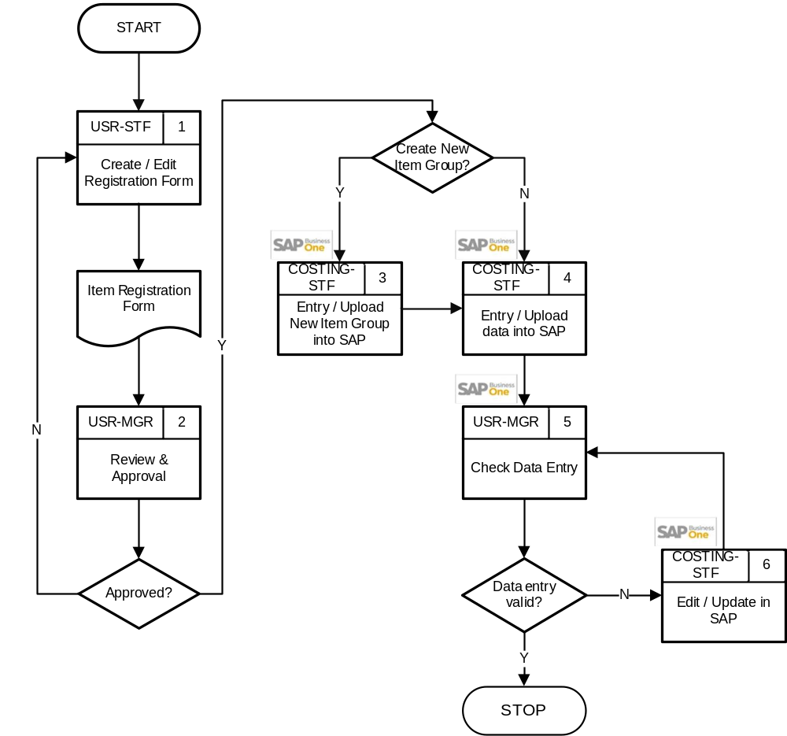
User:
- USR-STF : User Staff
- USR-MGR : User Manager
- COSTING-STF : Costing Staff

Explanation of Item Process Flow
No | Activity | Why | Who | How | Input | Output | Interface
 | Create / Edit Registration Form | Registrasi menambah item baru | USR-STF | Mengisi form registrasi item | Data item baru | Form registrasi item sudah diisi | Manual
 | Review & Approval | Untuk mengecek dan review form registrasi. | USR-MGR | Mengecek dan menyetujui registrasi data.  - Apabila data item perlu dilakukan perubahan, maka kembali ke no 1.  - Apabila data item disetujui, maka lanjut ke pengecekan berikutnya.  Apakah perlu Create Item Group atau Additional Item Group Baru?  - Jika iya, maka lanjut ke no 3.  - Jika tidak, maka lanjut ke no 4. | Form registrasi item sudah diisi | Form disetujui/tidak | Manual
 | Entry / Upload New Item Group into SAP | Memasukkan data Item Group atau Additional Item Group (Group 2 – Group 6) ke dalam sistem | COSTING-STF | Input data Item Group atau Additional Item Group (Group 2 – Group 6) yang berkaitan dengan item baru. Data Additional Item Group juga dapat di upload menggunakan Add-On Upload Item Master, dengan Mode: Upload Group berdasarkan template Excel. |  | Item Group atau Additional Item Group (Group 2 – Group 6) terdaftar ke dalam sistem | 
 | Entry / Upload data into SAP | Memasukkan data item ke dalam sistem | COSTING-STF | Input data berdasarkan form atau upload menggunakan Add-On Upload Item Master , dengan Mode: Upload Item berdasarkan template Excel. | Form registrasi item yang sudah disetujui | Item baru terdaftar ke dalam sistem
 | Check Data Entry | Memastikan data yang diinput sudah benar | USR-MGR | Mengecek data yang sudah diisi  - Jika perlu dilakukan revisi data maka lanjut ke no 5.  - Jika data item sudah sesuai, maka proses selesai. | Item data | Valid item data
 | Edit / Update in SAP | Revisi data jika ada salah saat penginputan | COSTING-STF | Edit data di dalam sistem, kemudian kembali ke no 5 agar dilakukan pemeriksaan terhadap data yang sudah di-update. | Invalid item data | Valid item data

Document Setting
-

Approval Rule
-

Alert/Notification
-

Journal Entry
-

List of Form
- Item Registration Form (Manual)

Remarks
- Item will be grouped based on Item Group.
No | Item Group
 | MATERIAL
 | FOAM
 | FINISH GOODS
 | SUPPLIES
 | EXPENDABLES
 | MERCHANDIES
 | SERVICES
 | FIXED ASSETS

- Untuk pengelompokan Item ditambahkan juga Additional Item Group, yaitu Group 2, Group 3, Group 4, Group 5, dan Group 6.
- Adapun contoh pengelompokan untuk Material adalah sebagai berikut:
Item Group |  | Group 2 |  | Group 3 |  | Group 4 |  |  | Group 5 |  | Group 6
MATERIAL | MT | ACCESSORIES | AC | COATS | CT | THREAD | TH | BROWN |  | BRWN | BONDED | BON
 |  |  |  | ELBEKA | EB | THREAD | TH | RED |  | 0RED | BONDED | BON
 |  |  |  |  |  |  |  | BLUE |  | BLUE | BONDED | BON
 |  |  |  |  |  |  |  | WHITE |  | WHTE | BONDED | BON
 |  |  |  |  |  |  |  |  |  |  | NYLON | NLN
 |  |  |  | LOCAL | LC | CORD | CD | BLACK |  | BLCK | 4MM | 004
 |  |  |  |  |  |  |  |  |  |  | AC138 | 138
 |  |  |  |  |  |  |  |  |  |  | LC05PD | 5PD
 |  |  |  |  |  |  |  | WHITE |  | WHTE | 4MM | 005
MATERIAL | MT | CHEMICAL | CH | ADDITIVE | AD | ANTI BACTERIAL | AB | NON APPLICABLE |  | NONE | NON APPLICABLE | NAN
 |  |  |  |  |  | BLUE | BU | NON APPLICABLE |  | NONE | NON APPLICABLE | NAN
 |  |  |  |  |  | PLASTICIZER | PS | NON APPLICABLE |  | NONE | NON APPLICABLE | NAN
 |  |  |  |  |  | WHITE | WH | NON APPLICABLE |  | NONE | NON APPLICABLE | NAN
 |  |  |  | BINDER | BD | ACRYLIC | AC | NON APPLICABLE |  | NONE | NON APPLICABLE | NAN
 |  |  |  |  |  | PRE POLYMER | PP | NON APPLICABLE |  | NONE | NON APPLICABLE | NAN
 |  |  |  |  |  | POLYURETHANE | PU | NON APPLICABLE |  | NONE | NON APPLICABLE | NAN
 |  |  |  | POLYOL | PL | PPG | PG | NON APPLICABLE |  | NONE | NON APPLICABLE | NAN
 |  |  |  |  |  | POP | PO | NON APPLICABLE |  | NONE | NON APPLICABLE | NAN
MATERIAL | MT | CMT | CM | CMT | CM | FABRIC | FB | NON ACCEPTABLE |  | NONE | NON ACCEPTABLE | NAN
 |  |  |  |  |  | OTHERS | OR | NON ACCEPTABLE |  | NONE | NON ACCEPTABLE | NAN
 |  |  |  |  |  | OBRASS THREAD | OT | NON ACCEPTABLE |  | NONE | NON ACCEPTABLE | NAN
 |  |  |  |  |  | PANEL FABRIC | PF | NON ACCEPTABLE |  | NONE | NON ACCEPTABLE | NAN
 |  |  |  |  |  | SLIDER | SD | NON ACCEPTABLE |  | NONE | NON ACCEPTABLE | NAN
 |  |  |  |  |  | STICHING THREAD | ST | NON ACCEPTABLE |  | NONE | NON ACCEPTABLE | NAN
 |  |  |  |  |  | VELCRO | VC | NON ACCEPTABLE |  | NONE | NON ACCEPTABLE | NAN
 |  |  |  |  |  | ZIPPER | ZP | NON ACCEPTABLE |  | NONE | NON ACCEPTABLE | NAN
MATERIAL | MT | FABRIC | FB | AGORA | AG | COMPACT | CP | AVENA |  | AVNA | 290 GR / M2 | 290
 |  |  |  |  |  |  |  |  |  |  | 310 GR / M2 | 310
 |  |  |  |  |  |  |  | MARFIL |  | MRFL | 310 GR / M2 | 310
 |  |  |  |  |  | CHEVIOT | CV | MUSGO |  | MSGO | 435 GRAM | 435
 |  |  |  |  |  |  |  | NAVY |  | NAVY | 435 GRAM | 435
 |  |  |  |  |  | THUNDER | TH | INTEGRAL |  | ITGL | 280 GR / M2 | 280
 |  |  |  |  |  |  |  | LIMESTONE |  | LMST | 280 GR / M2 | 280
 |  |  |  | OUTDURA | OT | DASHING | DS | BLACK |  | BLCK | 522 GR / M2 | 522
 |  |  |  |  |  |  |  | LATTE |  | LTTE | 522 GR / M2 | 522
 |  |  |  |  |  |  |  | NICKLE |  | NCKL | 522 GR / M2 | 522
 |  |  |  |  |  |  |  | NATURAL |  | NTRL | 522 GR / M2 | 522
 |  |  |  |  |  | RUMOR | RR | ALABASTER |  | ALBR | 640 GR / M2 | 640
 |  |  |  |  |  |  |  | DOVE |  | DOVE | 640 GR / M2 | 640
 |  |  |  |  |  |  |  | SNOW |  | SNOW | 640 GR / M2 | 640
 |  |  |  | PERENNIALS | PN | CANVAS WEAVE | CW | CHARCOAL |  | CHCL | 445 GR / M2 | 445
 |  |  |  |  |  |  |  | WHITE |  | WHTE | 445 GR / M2 | 445
 |  |  |  |  |  | TEXTURE LINEN SEA SALT | TS | BLANCA |  | BLNC | 460 GR / M2 | 460
 |  |  |  |  |  |  |  | PUMICE |  | PMCE | 460 GR / M2 | 460
MATERIAL | MT | FIBER | FR | HILON | HI | FELT | FT | WHITE |  | WHTE | FELT 170 GRAM | 170
 |  |  |  |  |  |  |  |  |  |  | FELT 180 GRAM | 180
 |  |  |  |  |  | POLYESTER | PR | WHITE |  | WHTE | BALL FIBER | BFR
 |  |  |  |  |  |  |  |  |  |  | CARDED FIBER | CFB
 |  |  |  |  |  |  |  |  |  |  | CRUSH MIX | CRM
 |  |  |  | INOCYCLE | IC | HDK | HD | WHITE |  | WHTE | HDK 350 GRAM | 350
 |  |  |  |  |  | HDU | HU | WHITE |  | WHTE | 250 GSM | 250
 |  |  |  |  |  | HDP | PD | GREEN |  | GREN | HDP 500 GRAM | 50
 |  |  |  |  |  |  |  | WHITE |  | WHTE | HDP 250 GRAM | 25
MATERIAL | MT | PACKING | PK | DONGJUNG | DJ | POLYBAG | PB | BLACK |  | BLCK | LDPE | LDP
 |  |  |  |  |  |  |  | CLEAR |  | CLER | HDPE | HDP
 |  |  |  | DAMASES | DS | OTHERS | OR | NON ACCEPTABLE |  | NONE | 5 GRAM | 005
 |  |  |  |  |  |  |  | NON ACCEPTABLE |  | NONE | 1000 GRAM | 100
 |  |  |  | LOCAL | LC | CARTON | CT | BROWN |  | BRWN | SINGLE WALL | SWL
 |  |  |  |  |  |  |  | NON ACCEPTABLE |  | NONE | NON ACCEPTABLE | NAN
 |  |  |  |  |  | KARUNG | KR | WHITE |  | WHTE | PLASTIK | PLS
 |  |  |  |  |  | STICKER BARCODE | SB | PINK |  | PINK | YUPO | YPO
 |  |  |  |  |  |  |  | WHITE |  | WHTE | YUPO | YPO
 |  |  |  |  |  |  |  | YELLOW |  | YLLW | YUPO | YPO

- Adapun contoh pengelompokan untuk Expendables, Supplies, dan Services adalah sebagai berikut:
Item Group |  | Group 2 |  | Group 3 |  | Group 4 |  | Group 5 |  |  | Group 6
EXPENDABLES | EX | CLEANING | CL | SOAP | SO | OTHERS | OR | NON ACCEPTABLE | NONE | NON ACCEPTABLE |  | NAN
 |  |  |  | TISSUE | TS | OTHERS | OR | NON ACCEPTABLE | NONE | NON ACCEPTABLE |  | NAN
EXPENDABLES | EX | CONSTRUCTION | CS | CONSTRUCTION | CS | OTHERS | OR | NON ACCEPTABLE | NONE | NON ACCEPTABLE |  | NAN
EXPENDABLES | EX | FOOD & BEVERAGE | FB | BEVERAGE | BV | OTHERS | OR | NON ACCEPTABLE | NONE | NON ACCEPTABLE |  | NAN
 |  |  |  | COFFEE | CF | OTHERS | OR | NON ACCEPTABLE | NONE | NON ACCEPTABLE |  | NAN
 |  |  |  | FRUITS | FR | OTHERS | OR | NON ACCEPTABLE | NONE | NON ACCEPTABLE |  | NAN
EXPENDABLES | EX | LOGISTIC COSTS | LC | EXPORT EXPENSE | EX | AIRFREIGHT | AF | NON ACCEPTABLE | NONE | NON ACCEPTABLE |  | NAN
 |  |  |  |  |  | CUSTOM CLEARANCE | CL | NON ACCEPTABLE | NONE | NON ACCEPTABLE |  | NAN
EXPENDABLES | EX | LEASE & RENTAL | LR | BUILDINGS | BD | OTHERS | OR | NON ACCEPTABLE | NONE | NON ACCEPTABLE |  | NAN
 |  |  |  | MACHINERY | MC | OTHERS | OR | NON ACCEPTABLE | NONE | NON ACCEPTABLE |  | NAN
EXPENDABLES | EX | MEDICINE | MD | MEDICINE | MD | OTHERS | OR | NON ACCEPTABLE | NONE | NON ACCEPTABLE |  | NAN
EXPENDABLES | EX | OTHERS | OS | OTHERS | OR | OTHERS | OR | NON ACCEPTABLE | NONE | NON ACCEPTABLE |  | NAN
EXPENDABLES | EX | REPAIR MAINTANANCE | RM | BUILDING | BD | OTHERS | OR | NON ACCEPTABLE | NONE | NON ACCEPTABLE |  | NAN
 |  |  |  | MACHINERY | MC | OTHERS | OR | NON ACCEPTABLE | NONE | NON ACCEPTABLE |  | NAN
 |  |  |  | OFFICE EQUIPMENTS | OE | OTHERS | OR | NON ACCEPTABLE | NONE | NON ACCEPTABLE |  | NAN
EXPENDABLES | EX | STATIONARY | ST | OTHERS | OT | OTHERS | OR | NON ACCEPTABLE | NONE | NON ACCEPTABLE |  | NAN
EXPENDABLES | EX | TRAVEL EXPENSES | TE | DOMESTIC | DM | ACCOMODATION | AC | NON ACCEPTABLE | NONE | NON ACCEPTABLE |  | NAN
 |  |  |  | OVERSEAS | OS | MEALS | ME | NON ACCEPTABLE | NONE | NON ACCEPTABLE |  | NAN
EXPENDABLES | EX | VEHICLE MAINTENANCE | VM | GAS | GS | OTHERS | OR | NON ACCEPTABLE | NONE | NON ACCEPTABLE |  | NAN
 |  |  |  | INSURANCE | IS | OTHERS | OR | NON ACCEPTABLE | NONE | NON ACCEPTABLE |  | NAN
SUPPLIES | SU | SPAREPART | SP | MECHANICAL | MC | NON SEWING | NS | TEE | TEE0 | PU |  | TPU
 |  |  |  |  |  |  |  | WATER MUR | WTMR | GALVANISH |  | GLV
 |  |  |  |  |  |  |  |  |  | PVC |  | PVC
 |  |  |  |  |  | SEWING | SW | PVC BOARD | PVCB | NON APPLICABLE |  | NAN
 |  |  |  |  |  |  |  | PVC FOAM | PVFO | NON APPLICABLE |  | NAN
 |  |  |  |  |  |  |  | RODA | RODA | NON APPLICABLE |  | NAN
 |  |  |  | TOOLS | TL | NON ACCEPTABLE | NA | SENDOK SEMEN | SNSM | NON APPLICABLE |  | NAN
 |  |  |  |  |  |  |  | SPRAY GUN | SPRY | NON APPLICABLE |  | NAN
SUPPLIES | SU | STATIONARY | ST | BOOK | BK | FOLIO | FL | NON ACCEPTABLE | NONE | NON ACCEPTABLE |  | NAN
 |  |  |  |  |  | OKTAVO | OK | NON ACCEPTABLE | NONE | NON ACCEPTABLE |  | NAN
 |  |  |  | PAPER | PP | CONTINUOUS FORM | CF | FULL | FULL | 2 PLY |  | 2PL
 |  |  |  |  |  |  |  |  |  | 3 PLY |  | 3PL
 |  |  |  |  |  |  |  | WARTEL | WRTL | 4 PLY |  | 4PL
 |  |  |  |  |  | HVS | HV | WHITE | WHTE | A4 |  | 0A4
 |  |  |  |  |  |  |  |  |  | F4 |  | 0F4
SERVICES | SV | CMT | CM | IN | IN | OTHERS | OR | NON ACCEPTABLE | NONE | NON ACCEPTABLE |  | NAN
 |  |  |  | OUT | OT | OTHERS | OR | NON ACCEPTABLE | NONE | NON ACCEPTABLE |  | NAN
SERVICES | SV | CASING | CS | 2025 | 25 | NON APPLICABLE | NA | NON APPLICABLE | NONE | NON APPLICABLE |  | NAN

- Adapun contoh pengelompokan untuk Foam adalah sebagai berikut:
Item Group |  | Group 2 |  | Group 3 |  | Group 4 |  | Group 5 |  | Group 6
FOAM | FO | COMPRIBAND | CB | ROLL | RL | 2 METER | 2M | NON APPLICABLE | NONE | NON APPLICABLE | NAN
 |  |  |  |  |  | 4 METER | 4M | NON APPLICABLE | NONE | NON APPLICABLE | NAN
 |  |  |  |  |  | 6 METER | 6M | NON APPLICABLE | NONE | NON APPLICABLE | NAN
 |  |  |  | SHEET | SH | 2 METER | 2M | NON APPLICABLE | NONE | NON APPLICABLE | NAN
 |  |  |  |  |  | NON APPLICABLE | NA | NON APPLICABLE | NONE | NON APPLICABLE | NAN
FOAM | FO | CARBON FILTER | CF | PPI 25 | 25 | NON APPLICABLE | NA | NON APPLICABLE | NONE | NON APPLICABLE | NAN
 |  |  |  | SHEET | SH | NON APPLICABLE | NA | NON APPLICABLE | NONE | NON APPLICABLE | NAN
FOAM | FO | UETR FR | FR | PPI 25 | 25 | BLACK | BL | NON APPLICABLE | NONE | NON APPLICABLE | NAN
 |  |  |  |  |  | CREAM | CR | NON APPLICABLE | NONE | NON APPLICABLE | NAN
 |  |  |  |  |  | LIGHT BLUE | LB | NON APPLICABLE | NONE | NON APPLICABLE | NAN
 |  |  |  | PPI 30 | 30 | BLACK | BL | NON APPLICABLE | NONE | NON APPLICABLE | NAN
 |  |  |  |  |  | CREAM | CR | NON APPLICABLE | NONE | NON APPLICABLE | NAN
FOAM | FO | UET FR | FU | PPI 25 | 25 | BLACK | BL | NON APPLICABLE | NONE | NON APPLICABLE | NAN
 |  |  |  |  |  | CREAM | CR | NON APPLICABLE | NONE | NON APPLICABLE | NAN
 |  |  |  |  |  | LIGHT BLUE | LB | NON APPLICABLE | NONE | NON APPLICABLE | NAN
 |  |  |  | PPI 45 | 45 | CREAM | CR | NON APPLICABLE | NONE | NON APPLICABLE | NAN
 |  |  |  |  |  | LIME | LM | NON APPLICABLE | NONE | NON APPLICABLE | NAN
FOAM | FO | HR | HR | DENSITY 35 | 35 | GREY | GY | NON APPLICABLE | NONE | NON APPLICABLE | NAN
FOAM | FO | NORMAL FOAM CA | NA | DENSITY 24 | 24 | YELLOW | YL | NON APPLICABLE | NONE | NON APPLICABLE | NAN
 |  |  |  | DENSITY 32 | 32 | YELLOW | YL | NON APPLICABLE | NONE | NON APPLICABLE | NAN
FOAM | FO | NORMAL FOAM | NF | DENSITY 16 | 16 | YELLOW | YL | NON APPLICABLE | NONE | NON APPLICABLE | NAN
 |  |  |  | DENSITY 20 | 20 | LIGHT BLUE | LB | NON APPLICABLE | NONE | NON APPLICABLE | NAN
 |  |  |  |  |  | YELLOW | YL | NON APPLICABLE | NONE | NON APPLICABLE | NAN
FOAM | FO | NORMAL FOAM FR | NR | DENSITY 24 | 24 | YELLOW | YL | NON APPLICABLE | NONE | NON APPLICABLE | NAN
 |  |  |  | DENSITY 32 | 32 | YELLOW | YL | NON APPLICABLE | NONE | NON APPLICABLE | NAN
 |  |  |  | DENSITY 40 | 40 | YELLOW | YL | NON APPLICABLE | NONE | NON APPLICABLE | NAN
FOAM | FO | QDF | QF | EXTRA SUPER SOFT | ES | PURPLE | PL | NON APPLICABLE | NONE | NON APPLICABLE | NAN
 |  |  |  | FIRM | FM | LIGHT ORANGE | LO | NON APPLICABLE | NONE | NON APPLICABLE | NAN
FOAM | FO | QDF FR | QR | FIRM | FM | LIGHT ORANGE | LO | NON APPLICABLE | NONE | NON APPLICABLE | NAN
 |  |  |  | MEDIUM | MD | YELLOW | YL | NON APPLICABLE | NONE | NON APPLICABLE | NAN
FOAM | FO | REBONDED | RF | DENSITY 100 | 10 | NORMAL FOAM | NF | NON APPLICABLE | NONE | NON APPLICABLE | NAN
 |  |  |  |  |  | QUICKDRY FOAM | QF | NON APPLICABLE | NONE | NON APPLICABLE | NAN
 |  |  |  | DENSITY 120 | 12 | QUICKDRY FOAM | QF | NON APPLICABLE | NONE | NON APPLICABLE | NAN
FOAM | FO | UETR | UR | PPI 60 | 60 | PURPLE | PL | NON APPLICABLE | NONE | NON APPLICABLE | NAN
 |  |  |  |  |  | YELLOW | YL | NON APPLICABLE | NONE | NON APPLICABLE | NAN
FOAM | FO | UET | UT | PPI 25 | 25 | BLACK | BL | NON APPLICABLE | NONE | NON APPLICABLE | NAN
 |  |  |  |  |  | CREAM | CR | NON APPLICABLE | NONE | NON APPLICABLE | NAN

- Adapun contoh pengelompokan untuk Finish Goods adalah sebagai berikut:
Item Group |  | Group 2 |  | Group 3 |  | Group 4 |  | Group 5 |  | Group 6
FINISHED GOODS | FG | BERIA | BR | NON APPLICABLE | NA | NON APPLICABLE | NA | NON APPLICABLE | NONE | NON APPLICABLE | NAN
FINISHED GOODS | FG | COMPRIBAND | CB | NON APPLICABLE | NA | NON APPLICABLE | NA | NON APPLICABLE | NONE | NON APPLICABLE | NAN
FINISHED GOODS | FG | CARBON FILTER | CF | NON APPLICABLE | NA | NON APPLICABLE | NA | NON APPLICABLE | NONE | NON APPLICABLE | NAN
FINISHED GOODS | FG | CORE | CR | 2025 | 25 | ANCONA | AC | DINING ARM CHAIR | DAC0 | NON APPLICABLE | NAN
 |  |  |  |  |  |  |  | 84 SOFA | S084 | NON APPLICABLE | NAN
 |  |  |  |  |  |  |  | 96 SOFA | S096 | NON APPLICABLE | NAN
 |  |  |  |  |  | AEGEAN | AG | 51 DINING BENCH | B051 | NON APPLICABLE | NAN
 |  |  |  |  |  |  |  | 63 DINING BENCH | B063 | NON APPLICABLE | NAN
 |  |  |  |  |  |  |  | CLASSIC 109 SOFA | C109 | NON APPLICABLE | NAN
 |  |  |  |  |  |  |  | CLASSIC 2 SEATER ARMLESS SOFA | C2AS | NON APPLICABLE | NAN
 |  |  |  |  |  | MARBELLA | MB | 72 DINING BENCH | B072 | NON APPLICABLE | NAN
 |  |  |  |  |  |  |  | 84 DINING BENCH | B084 | NON APPLICABLE | NAN
FINISHED GOODS | FG | CASING | CS | 2025 | 25 | ANCONA | AC | DINING ARM CHAIR | DAC0 | ROSEMOUNT BARK | RBK
 |  |  |  |  |  |  |  | 84 SOFA | S084 | EDEN FLAX | EFL
 |  |  |  |  |  |  |  |  |  | EDEN SNOW | ESN
 |  |  |  |  |  |  |  |  |  | ROSEMOUNT BARK | RBK
 |  |  |  |  |  | BEAUMONT | BE | LOUNGE CHAIR | LNC0 | ROSEMOUNT GRAPHITE | RGT
 |  |  |  |  |  |  |  |  |  | SHARDAI ZINC | SZI
 |  |  |  |  |  |  |  |  |  | TWILLY PEARL | TPE
 |  |  |  |  |  |  |  | OTTOMAN | OTT0 | SHARDAI ZINC | SZI
 |  |  |  |  |  |  |  |  |  | TWILLY PEARL | TPE
FINISHED GOODS | FG | CUT TO SIZE | CT | 2025 | 25 | NON APPLICABLE | NA | NON APPLICABLE | NONE | NON APPLICABLE | NAN
 |  |  |  | 2026 | 26 | NON APPLICABLE | NA | NON APPLICABLE | NONE | NON APPLICABLE | NAN
FINISHED GOODS | FG | CUSHION | CU | 2025 | 25 | BAL HARBOUR | BH | ARMLESS CHAIR | ARC0 | EDEN OYSTER | EOY
 |  |  |  |  |  |  |  |  |  | EDEN SNOW | ESN
 |  |  |  |  |  |  |  |  |  | PANAMA FOSSIL | PFS
 |  |  |  |  |  |  |  | 89 SOFA | S089 | PANAMA FOSSIL | PFS
 |  |  |  |  |  |  |  |  |  | ROSEMOUNT GRAPHITE | RGT
 |  |  |  |  |  |  |  |  |  | SHARDAI ZINC | SZI
 |  |  |  |  |  | LAUREL | LU | LOUNGE CHAIR | LNC0 | PERENNIALS DOVE | PDV
 |  |  |  |  |  |  |  |  |  | PERENNIALS NATURAL | PNT
 |  |  |  |  |  |  |  | 108 SOFA | S108 | PERENNIALS DOVE | PDV
 |  |  |  |  |  |  |  |  |  | PERENNIALS NATURAL | PNT
 |  |  |  |  |  |  |  |  |  | PERENNIALS WHITE | PWT
FINISHED GOODS |  | COVER | CV | 2025 | 25 | ANAMI | AM | 3 SEATER LEFT ARM RETURN SOFA | 3SLN | COMPACT SPECIAL PIEDRA | CSP
 |  |  |  |  |  |  |  | 3 SEATER RIGHT ARM RETURN SOFA | 3SRN | COMPACT SPECIAL PIEDRA | CSP
 |  |  |  |  |  |  |  | ARMLESS SOFA | ARS0 | COMPACT SPECIAL PIEDRA | CSP
 |  |  |  |  |  | CALUSA | CL | DAYBED | DYB0 | COMPACT SPECIAL PIEDRA | CSP
 |  |  |  |  |  | CANYON | CN | 2 SEATER LEFT ARM SOFA | 2SLA | COMPACT SPECIAL PIEDRA | CSP
 |  |  |  |  |  |  |  | 2 SEATER LEFT ARM RETURN SOFA | 2SLN | COMPACT SPECIAL PIEDRA | CSP
 |  |  |  |  |  | ELIO | EL | LOUNGE CHAIR | LNC0 | COMPACT PIEDRA | CPD
 |  |  |  |  |  |  |  |  |  | COMPACT SPECIAL PIEDRA | CSP
 |  |  |  |  |  | MONTEGO | MN | BARSTOOL | BRS0 | COMPACT SPECIAL PIEDRA | CSP
 |  |  |  |  |  |  |  | 36 SQ BARTABLE | BT36 | COMPACT SPECIAL PIEDRA | CSP

- Adapun contoh pengelompokan untuk Fixed Asset adalah sebagai berikut:
Item Group |  | Group 2 |  | Group 3 |  | Group 4 |  | Group 5 |  | Group 6
FIXED ASSET | FA | ASSET | AT | BUILDING | BD | OTHERS | OR | NON ACCEPTABLE | NONE | NON ACCEPTABLE | NAN
 |  |  |  | CIP BUILDING | CD | OTHERS | OR | NON ACCEPTABLE | NONE | NON ACCEPTABLE | NAN
 |  |  |  | CIP STRUCTURE | CS | OTHERS | OR | NON ACCEPTABLE | NONE | NON ACCEPTABLE | NAN
 |  |  |  | LAND | LD | OTHERS | OR | NON ACCEPTABLE | NONE | NON ACCEPTABLE | NAN
 |  |  |  | MACHINERY | MC | OTHERS | OR | NON ACCEPTABLE | NONE | NON ACCEPTABLE | NAN
 |  |  |  | OFFICE EQUPMENT | OE | OTHERS | OR | NON ACCEPTABLE | NONE | NON ACCEPTABLE | NAN
 |  |  |  | STRUCTURE | SR | OTHERS | OR | NON ACCEPTABLE | NONE | NON ACCEPTABLE | NAN
 |  |  |  | TOOLS & EQUIPMENT | TE | OTHERS | OR | NON ACCEPTABLE | NONE | NON ACCEPTABLE | NAN
 |  |  |  | VEHICLES | VH | OTHERS | OR | NON ACCEPTABLE | NONE | NON ACCEPTABLE | NAN

- Penomoran Item akan otomatis berdasarkan group di atas, dengan Format AABBCCDDEEEEFFFGGGG
  - AA: 2 Digit Item Group Prefix
  - BB: 2 Digit Group 2
  - CC: 2 Digit Group 3
  - DD: 2 Digit Group 4
  - EEEE: 4 Digit Group 5
  - FFF: 3 Digit Group 6
  - GGGG: 4 Digit Running Number
  - Contoh: MTFBAGLSMRFL2600001
- Advanced G/L Account Determination untuk Item Group Expendables, berdasarkan BP Group & Additional Item Group (Group 2-4):
No | Description | BP Group | Group 2 | Group 3 | Group 4 | Expense Account
 | Expendables (CL-Cleaning Tools) | All | CL | CT | All | 532051300 | Office Supplies-Cleaning
 | Expendables (CL-Soap) | All | CL | SO | All | 532051300 | Office Supplies-Cleaning
 | Expendables (CL-Tissue) | All | CL | TS | All | 532051300 | Office Supplies-Cleaning
 | Expendables (CS-Construction) | All | CS | CS | All | 532053900 | Utilities-Others
 | Expendables (FB-Beverage) | All | FB | BV | All | 531090210 | Welfare expense-Meal
 | Expendables (FB-Coffee) | All | FB | CF | All | 531090210 | Welfare expense-Meal
 | Expendables (FB-Food) | All | FB | FD | All | 531090210 | Welfare expense-Meal
 | Expendables (FB-Fruits) | All | FB | FR | All | 531090210 | Welfare expense-Meal
 | Expendables (FB-Sugar) | All | FB | SG | All | 531090210 | Welfare expense-Meal
 | Expendables (FB-Water) | All | FB | WT | All | 531090210 | Welfare expense-Meal
 | Expendables (LC-Export Expense) Airfreight | All | LC | EX | AF | 522030300 | Export-Airfreight
 | Expendables (LC-Export Expense) Custom Clearance | All | LC | EX | CL | 522030500 | Export-Custom clearance
 | Expendables (LC-Export Expense) Inland Transportation | All | LC | EX | IT | 522030100 | Export-Inland transportation
 | Expendables (LC-Export Expense) L/C Charge | All | LC | EX | LC | 522030400 | Export-L/C charge
 | Expendables (LC-Export Expense) Ocean Freight | All | LC | EX | OC | 522030200 | Export-Ocean freight
 | Expendables (LC-Export Expense) Others | All | LC | EX | OR | 522030900 | Export-Others
 | Expendables (LC-Freight Expense) | All | LC | FE | All | 522010310 | Freight Expense-3rd parties-Shipping charge
 | Expendables (LR-Buildings) | All | LR | BD | All | 532033200 | Lease & Rental-Building
 | Expendables (LR-Machinery) | All | LR | MC | All | 532033400 | Lease & Rental-Machinery
 | Expendables (LR-Office Equipments) | All | LR | OE | All | 532033700 | Lease & Rental-Office Equipments
 | Expendables (LR-Structures) | All | LR | SR | All | 532033300 | Lease & Rental-Structures
 | Expendables (LR-Tools And Equipments) | All | LR | TE | All | 532033600 | Lease & Rental-Tools and Equipments
 | Expendables (LR-Vehicles) | All | LR | VH | All | 532033500 | Lease & Rental-Vehicles
 | Expendables (MD-Medicine) | All | MD | MD | All | 532051200 | Office Supplies-Medicine
 | Expendables (OS-Others) | All | OS | OR | All | 532051900 | Office Supplies-Others
 | Expendables (RM-Buildings) | All | RM | BD | All | 532055200 | Repairs & Maintenance-Buildings
 | Expendables (RM-Machinery) | All | RM | MC | All | 532055400 | Repairs & Maintenance-Machinery
 | Expendables (RM-Office Equipments) | All | RM | OE | All | 532055700 | Repairs & Maintenance-Office Equipments
 | Expendables (RM-Others) | All | RM | OR | All | 532055900 | Repairs & Maintenance-Others
 | Expendables (RM-Structures) | All | RM | SR | All | 532055300 | Repairs & Maintenance-Structures
 | Expendables (RM-Tools And Equipments) | All | RM | TE | All | 532055600 | Repairs & Maintenance-Tools and Equipments
 | Expendables (ST-Others) | All | ST | OT | All | 532051900 | Office Supplies-Others
 | Expendables (ST-Pens) | All | ST | PN | All | 532051100 | Office Supplies-Stationery
 | Expendables (ST-Papers) | All | ST | PR | All | 532051100 | Office Supplies-Stationery
 | Expendables (TE-Domestic) Accomodation | All | TE | DM | AC | 532059130 | Travel Expense-Domestic--Accommodation
 | Expendables (TE-Domestic) Meals | All | TE | DM | ME | 532059110 | Travel Expense-Domestic-Meals
 | Expendables (TE-Domestic) Others | All | TE | DM | OR | 532059190 | Travel Expense-Domestic-Others
 | Expendables (TE-Domestic) Transportation | All | TE | DM | TR | 532059120 | Travel Expense-Domestic-Transportation
 | Expendables (TE-Overseas) Accomodation | All | TE | OS | AC | 532059530 | Travel Expense-Overseas-Accomodation
 | Expendables (TE-Overseas) Meals | All | TE | OS | ME | 532059510 | Travel Expense-Overseas-Meals
 | Expendables (TE-Overseas) Others | All | TE | OS | OR | 532059590 | Travel Expense-Overseas-Others
 | Expendables (TE-Overseas) Transportation | All | TE | OS | TR | 532059520 | Travel Expense-Overseas-Transportation
 | Expendables (VM-Gas) | All | VM | GS | All | 532015100 | Vehicle Maintenance-Gas
 | Expendables (VM-Insurance) | All | VM | IS | All | 532015300 | Vehicle maintenance-Insurance
 | Expendables (VM-Others) | All | VM | OR | All | 532015900 | Vehicle maintenance-Others
 | Expendables (VM-Parking) | All | VM | PC | All | 532015500 | Vehicle maintenance-Parking
 | Expendables (VM-Repair) | All | VM | RP | All | 532015200 | Vehicle maintenance-Repair
 | Expendables (VM-Toll) | All | VM | TL | All | 532015400 | Vehicle maintenance-Toll

- Advanced G/L Account Determination untuk Item Group Finish Goods, berdasarkan BP Group & Additional Item Group (Group 2-4):
No | Description | BP Group | Group 2 | Group 3 | Group 4 | Expense Account | Revenue Account | Inventory Account | COGS Account | Alloc. Account | Variance Account | Price Diff. Account | Neg. Inv. Adj. Account
 | Finish Goods All | All | All | All | All | 421011100 | 411011100 | 112110100 | 421011100 | 210120100 | 421021010 | 421021010 | 421021010
 | Finish Goods Customer Domestic | C Domestic | All | All | All | 421011100 | 411011100 | 112110100 | 421011100 | 210120100 | 421021010 | 421021010 | 421021010
 | Finish Goods Customer Interco | C Intercompany | All | All | All | 421011100 | 411015100 | 112110100 | 421011100 | 210120300 | 421021010 | 421021010 | 421021010
 | Finish Goods Customer Overseas | C Overseas | All | All | All | 421011100 | 411013100 | 112110100 | 421011100 | 210120100 | 421021010 | 421021010 | 421021010
 | Finish Goods Vendor Domestic | V Domestic | All | All | All | 421011100 | 411011100 | 112110100 | 421011100 | 210120100 | 421021010 | 421021010 | 421021010
 | Finish Goods Vendor Interco | V Intercompany | All | All | All | 421011100 | 411015100 | 112110100 | 421011100 | 210120300 | 421021010 | 421021010 | 421021010
 | Finish Goods Vendor Overseas | V Overseas | All | All | All | 421011100 | 411013100 | 112110100 | 421011100 | 210120100 | 421021010 | 421021010 | 421021010

No | Description | Sales Return Account | Exch. Rate Diff Account | Goods Clearing Account | Inventory Offset P&L Account | Expense Clearing Account | Sales Credit Account | Purchase Credit Account | Inventory Offset - Decr. Acct | Inventory Offset - Incr. Acct | WIP Inventory Account | WIP Inv. Variance Account
 | Finish Goods All | 112110100 |  | 421021010 | 210120100 | 210120800 | 411011100 | 210120100 | 421023100 | 421023100 | 112139900 | 519010100
 | Finish Goods Customer Domestic | 112110100 |  | 421021010 | 210120100 | 210120800 | 411011100 | 210120100 | 421023100 | 421023100 | 112139900 | 519010100
 | Finish Goods Customer Interco | 112110100 |  | 421021010 | 210120300 | 210120800 | 411015100 | 210120300 | 421023100 | 421023100 | 112139900 | 519010100
 | Finish Goods Customer Overseas | 112110100 |  | 421021010 | 210120100 | 210120800 | 411013100 | 210120100 | 421023100 | 421023100 | 112139900 | 519010100
 | Finish Goods Vendor Domestic | 112110100 |  | 421021010 | 210120100 | 210120800 | 411011100 | 210120100 | 421023100 | 421023100 | 112139900 | 519010100
 | Finish Goods Vendor Interco | 112110100 |  | 421021010 | 210120300 | 210120800 | 411015100 | 210120300 | 421023100 | 421023100 | 112139900 | 519010100
 | Finish Goods Vendor Overseas | 112110100 |  | 421021010 | 210120100 | 210120800 | 411013100 | 210120100 | 421023100 | 421023100 | 112139900 | 519010100

No | Description | WIP Offset P&L Account | Shipped Goods Account | Stock In Transit Account
 | Finish Goods All | 112139900 | 112190100 | 210120100
 | Finish Goods Customer Domestic | 112139900 | 112190100 | 210120100
 | Finish Goods Customer Interco | 112139900 | 112190100 | 210120300
 | Finish Goods Customer Overseas | 112139900 | 112190100 | 210120100
 | Finish Goods Vendor Domestic | 112139900 | 112190100 | 210120100
 | Finish Goods Vendor Interco | 112139900 | 112190100 | 210120300
 | Finish Goods Vendor Overseas | 112139900 | 112190100 | 210120100

Keterangan:
- 112110100 - Finished goods
- 112139900 - Valuation allowance-WIP
- 112190100 - Goods in transit-Finished Goods
- 210120100 - Outstanding Invoices-Suppliers
- 210120300 - Outstanding Invoices-Affiliated Companies
- 210120800 - Outstanding Invoices/Freights
- 411011100 - Sales from Finished goods-Domestic
- 411013100 - Sales from Finished goods-Foreign
- 411015100 - Sales from Finished goods-Interco.
- 421011100 - COGS-Finished goods
- 421021010 - COGS-Price diff-Finished goods
- 421023100 - COGS-Disposal-Finished goods
- 519010100 - WIP Variances

- Advanced G/L Account Determination untuk Item Group Foam, berdasarkan BP Group & Additional Item Group (Group 2-4):
No | Description | BP Group | Group 2 | Group 3 | Group 4 | Expense Account | Revenue Account | Inventory Account | COGS Account | Alloc. Account | Variance Account | Price Diff. Account | Neg. Inv. Adj. Account
 | Foam All (FG) | All | All | All | All | 421012100 | 411021100 | 112120100 | 421012100 | 210120100 | 421021020 | 421021020 | 421021020
 | Foam All (UET FR) | All | FU | All | All | 421012100 | 411021100 | 112120100 | 421012100 | 210120100 | 421021020 | 421021020 | 421021020
 | Foam All (UET) | All | UT | All | All | 421012100 | 411021100 | 112120100 | 421012100 | 210120100 | 421021020 | 421021020 | 421021020
 | Foam Customer Domestic (FG) | C Domestic | All | All | All | 421011100 | 411011100 | 112110100 | 421011100 | 210120100 | 421021010 | 421021010 | 421021010
 | Foam Customer Domestic (UET FR) | C Domestic | FU | All | All | 421012100 | 411021100 | 112120100 | 421012100 | 210120100 | 421021020 | 421021020 | 421021020
 | Foam Customer Domestic (UET) | C Domestic | UT | All | All | 421012100 | 411021100 | 112120100 | 421012100 | 210120100 | 421021020 | 421021020 | 421021020
 | Foam Customer Interco (FG) | C Intercompany | All | All | All | 421011100 | 411015100 | 112110100 | 421011100 | 210120300 | 421021010 | 421021010 | 421021010
 | Foam Customer Interco (UET FR) | C Intercompany | FU | All | All | 421012100 | 411025100 | 112120100 | 421012100 | 210120300 | 421021020 | 421021020 | 421021020
 | Foam Customer Interco (UET) | C Intercompany | UT | All | All | 421012100 | 411025100 | 112120100 | 421012100 | 210120300 | 421021020 | 421021020 | 421021020
 | Foam Customer Overseas (FG) | C Overseas | All | All | All | 421011100 | 411013100 | 112110100 | 421011100 | 210120100 | 421021010 | 421021010 | 421021010
 | Foam Customer Overseas (UET FR) | C Overseas | FU | All | All | 421012100 | 411023100 | 112120100 | 421012100 | 210120100 | 421021020 | 421021020 | 421021020
 | Foam Customer Overseas (UET) | C Overseas | UT | All | All | 421012100 | 411023100 | 112120100 | 421012100 | 210120100 | 421021020 | 421021020 | 421021020
 | Foam Vendor Domestic (FG) | V Domestic | All | All | All | 421011100 | 411011100 | 112110100 | 421011100 | 210120100 | 421021010 | 421021010 | 421021010
 | Foam Vendor Domestic (UET FR) | V Domestic | FU | All | All | 421012100 | 411021100 | 112120100 | 421012100 | 210120100 | 421021020 | 421021020 | 421021020
 | Foam Vendor Domestic (UET) | V Domestic | UT | All | All | 421012100 | 411021100 | 112120100 | 421012100 | 210120100 | 421021020 | 421021020 | 421021020
 | Foam Vendor Interco (FG) | V Intercompany | All | All | All | 421011100 | 411015100 | 112110100 | 421011100 | 210120300 | 421021010 | 421021010 | 421021010
 | Foam Vendor Interco (UET FR) | V Intercompany | FU | All | All | 421012100 | 411025100 | 112120100 | 421012100 | 210120300 | 421021020 | 421021020 | 421021020
 | Foam Vendor Interco (UET) | V Intercompany | UT | All | All | 421012100 | 411025100 | 112120100 | 421012100 | 210120300 | 421021020 | 421021020 | 421021020
 | Foam Vendor Overseas (FG) | V Overseas | All | All | All | 421011100 | 411013100 | 112110100 | 421011100 | 210120100 | 421021010 | 421021010 | 421021010
 | Foam Vendor Overseas (UET FR) | V Overseas | FU | All | All | 421012100 | 411023100 | 112120100 | 421012100 | 210120100 | 421021020 | 421021020 | 421021020
 | Foam Vendor Overseas (UET) | V Overseas | UT | All | All | 421012100 | 411023100 | 112120100 | 421012100 | 210120100 | 421021020 | 421021020 | 421021020

No | Description | Sales Return Account | Exch. Rate Diff Account | Goods Clearing Account | Inventory Offset P&L Account | Expense Clearing Account | Sales Credit Account | Purchase Credit Account | Inventory Offset - Decr. Acct | Inventory Offset - Incr. Acct | WIP Inventory Account | WIP Inv. Variance Account
 | Foam All (FG) | 112120100 |  | 421021020 | 210120100 | 210120800 | 411021100 | 210120100 | 421023200 | 421023200 | 112139900 | 519010100
 | Foam All (UET FR) | 112120100 |  | 421021020 | 210120100 | 210120800 | 411021100 | 210120100 | 421023200 | 421023200 | 112139900 | 519010100
 | Foam All (UET) | 112120100 |  | 421021020 | 210120100 | 210120800 | 411021100 | 210120100 | 421023200 | 421023200 | 112139900 | 519010100
 | Foam Customer Domestic (FG) | 112110100 |  | 421021010 | 210120100 | 210120800 | 411011100 | 210120100 | 421023100 | 421023100 | 112139900 | 519010100
 | Foam Customer Domestic (UET FR) | 112120100 |  | 421021020 | 210120100 | 210120800 | 411021100 | 210120100 | 421023200 | 421023200 | 112139900 | 519010100
 | Foam Customer Domestic (UET) | 112120100 |  | 421021020 | 210120100 | 210120800 | 411021100 | 210120100 | 421023200 | 421023200 | 112139900 | 519010100
 | Foam Customer Interco (FG) | 112110100 |  | 421021010 | 210120300 | 210120800 | 411015100 | 210120300 | 421023100 | 421023100 | 112139900 | 519010100
 | Foam Customer Interco (UET FR) | 112120100 |  | 421021020 | 210120300 | 210120800 | 411025100 | 210120300 | 421023200 | 421023200 | 112139900 | 519010100
 | Foam Customer Interco (UET) | 112120100 |  | 421021020 | 210120300 | 210120800 | 411025100 | 210120300 | 421023200 | 421023200 | 112139900 | 519010100
 | Foam Customer Overseas (FG) | 112110100 |  | 421021010 | 210120100 | 210120800 | 411013100 | 210120100 | 421023100 | 421023100 | 112139900 | 519010100
 | Foam Customer Overseas (UET FR) | 112120100 |  | 421021020 | 210120100 | 210120800 | 411023100 | 210120100 | 421023200 | 421023200 | 112139900 | 519010100
 | Foam Customer Overseas (UET) | 112120100 |  | 421021020 | 210120100 | 210120800 | 411023100 | 210120100 | 421023200 | 421023200 | 112139900 | 519010100
 | Foam Vendor Domestic (FG) | 112110100 |  | 421021010 | 210120100 | 210120800 | 411011100 | 210120100 | 421023100 | 421023100 | 112139900 | 519010100
 | Foam Vendor Domestic (UET FR) | 112120100 |  | 421021020 | 210120100 | 210120800 | 411021100 | 210120100 | 421023200 | 421023200 | 112139900 | 519010100
 | Foam Vendor Domestic (UET) | 112120100 |  | 421021020 | 210120100 | 210120800 | 411021100 | 210120100 | 421023200 | 421023200 | 112139900 | 519010100
 | Foam Vendor Interco (FG) | 112110100 |  | 421021010 | 210120300 | 210120800 | 411015100 | 210120300 | 421023100 | 421023100 | 112139900 | 519010100
 | Foam Vendor Interco (UET FR) | 112120100 |  | 421021020 | 210120300 | 210120800 | 411025100 | 210120300 | 421023200 | 421023200 | 112139900 | 519010100
 | Foam Vendor Interco (UET) | 112120100 |  | 421021020 | 210120300 | 210120800 | 411025100 | 210120300 | 421023200 | 421023200 | 112139900 | 519010100
 | Foam Vendor Overseas (FG) | 112110100 |  | 421021010 | 210120100 | 210120800 | 411013100 | 210120100 | 421023100 | 421023100 | 112139900 | 519010100
 | Foam Vendor Overseas (UET FR) | 112120100 |  | 421021020 | 210120100 | 210120800 | 411023100 | 210120100 | 421023200 | 421023200 | 112139900 | 519010100
 | Foam Vendor Overseas (UET) | 112120100 |  | 421021020 | 210120100 | 210120800 | 411023100 | 210120100 | 421023200 | 421023200 | 112139900 | 519010100

No | Description | WIP Offset P&L Account | Shipped Goods Account | Stock In Transit Account
 | Foam All (FG) | 112139900 | 112190200 | 210120100
 | Foam All (UET FR) | 112139900 | 112190200 | 210120100
 | Foam All (UET) | 112139900 | 112190200 | 210120100
 | Foam Customer Domestic (FG) | 112139900 | 112190100 | 210120100
 | Foam Customer Domestic (UET FR) | 112139900 | 112190200 | 210120100
 | Foam Customer Domestic (UET) | 112139900 | 112190200 | 210120100
 | Foam Customer Interco (FG) | 112139900 | 112190100 | 210120300
 | Foam Customer Interco (UET FR) | 112139900 | 112190200 | 210120300
 | Foam Customer Interco (UET) | 112139900 | 112190200 | 210120300
 | Foam Customer Overseas (FG) | 112139900 | 112190100 | 210120100
 | Foam Customer Overseas (UET FR) | 112139900 | 112190200 | 210120100
 | Foam Customer Overseas (UET) | 112139900 | 112190200 | 210120100
 | Foam Vendor Domestic (FG) | 112139900 | 112190100 | 210120100
 | Foam Vendor Domestic (UET FR) | 112139900 | 112190200 | 210120100
 | Foam Vendor Domestic (UET) | 112139900 | 112190200 | 210120100
 | Foam Vendor Interco (FG) | 112139900 | 112190100 | 210120300
 | Foam Vendor Interco (UET FR) | 112139900 | 112190200 | 210120300
 | Foam Vendor Interco (UET) | 112139900 | 112190200 | 210120300
 | Foam Vendor Overseas (FG) | 112139900 | 112190100 | 210120100
 | Foam Vendor Overseas (UET FR) | 112139900 | 112190200 | 210120100
 | Foam Vendor Overseas (UET) | 112139900 | 112190200 | 210120100

Keterangan:
- 112110100 - Finished goods
- 112120100 - Unfinished goods
- 112139900 - Valuation allowance-WIP
- 112190100 - Goods in transit-Finished Goods
- 112190200 - Goods in transit-Unfinished goods
- 210120100 - Outstanding Invoices-Suppliers
- 210120300 - Outstanding Invoices-Affiliated Companies
- 210120800 - Outstanding Invoices/Freights
- 411011100 - Sales from Finished goods-Domestic
- 411013100 - Sales from Finished goods-Foreign
- 411015100 - Sales from Finished goods-Interco.
- 411021100 - Sales from Unfinished goods-Domestic
- 411023100 - Sales from Unfinished goods-Foreign
- 411025100 - Sales from Unfinished goods-Interco.
- 421011100 - COGS-Finished goods
- 421012100 - COGS-Unfinished goods
- 421021010 - COGS-Price diff-Finished goods
- 421021020 - COGS-Price diff-Unfinished goods
- 421023100 - COGS-Disposal-Finished goods
- 421023200 - COGS-Disposal-Unfinished goods
- 519010100 - WIP Variances

- Advanced G/L Account Determination untuk Item Group Material, berdasarkan BP Group & Additional Item Group (Group 2-4):
No | Description | BP Group | Group 2 | Group 3 | Group 4 | Expense Account | Revenue Account | Inventory Account | COGS Account | Alloc. Account | Variance Account | Price Diff. Account | Neg. Inv. Adj. Account
 | Material All (Sub-Accessories) | All | AC | All | All | 421016900 | 411061900 | 112160900 | 421016900 | 210120100 | 421021060 | 421021060 | 421021060
 | Material ALL (RM) | All | All | All | All | 421015900 | 411051900 | 112150900 | 421015900 | 210120100 | 421021059 | 421021059 | 421021059
 | Material All (Sub-Packing) | All | PK | All | All | 421016900 | 411061900 | 112160900 | 421016900 | 210120100 | 421021060 | 421021060 | 421021060
 | Material Customer Domestic (Sub-Accessories) | C Domestic | AC | All | All | 421016900 | 411061900 | 112160900 | 421016900 | 210120100 | 421021060 | 421021060 | 421021060
 | Material Customer Domestic (RM) | C Domestic | All | All | All | 421015900 | 411051900 | 112150900 | 421015900 | 210120100 | 421021059 | 421021059 | 421021059
 | Material Customer Domestic (Sub-Packing) | C Domestic | PK | All | All | 421016900 | 411061900 | 112160900 | 421016900 | 210120100 | 421021060 | 421021060 | 421021060
 | Material Customer Interco (Sub-Accessories) | C Intercompany | AC | All | All | 421016900 | 411065900 | 112160900 | 421016900 | 210120300 | 421021060 | 421021060 | 421021060
 | Material Customer Interco (RM) | C Intercompany | All | All | All | 421015100 | 411051100 | 112150100 | 421015100 | 210120300 | 421021050 | 421021050 | 421021050
 | Material Customer Interco (Sub-Packing) | C Intercompany | PK | All | All | 421016900 | 411065900 | 112160900 | 421016900 | 210120300 | 421021060 | 421021060 | 421021060
 | Material Customer Overseas (Sub-Accessories) | C Overseas | AC | All | All | 421016900 | 411063900 | 112160900 | 421016900 | 210120100 | 421021060 | 421021060 | 421021060
 | Material Customer Overseas (RM) | C Overseas | All | All | All | 421015900 | 411053900 | 112150900 | 421015900 | 210120100 | 421021059 | 421021059 | 421021059
 | Material Customer Overseas (Sub-Packing) | C Overseas | PK | All | All | 421016900 | 411063900 | 112160900 | 421016900 | 210120100 | 421021060 | 421021060 | 421021060
 | Material Vendor Domestic (Sub-Accessories) | V Domestic | AC | All | All | 421016900 | 411061900 | 112160900 | 421016900 | 210120100 | 421021060 | 421021060 | 421021060
 | Material Vendor Domestic (RM) | V Domestic | All | All | All | 421015900 | 411051900 | 112150900 | 421015900 | 210120100 | 421021059 | 421021059 | 421021059
 | Material Vendor Domestic (Sub-Packing) | V Domestic | PK | All | All | 421016900 | 411061900 | 112160900 | 421016900 | 210120100 | 421021060 | 421021060 | 421021060
 | Material Vendor Interco (Sub-Accessories) | V Intercompany | AC | All | All | 421016900 | 411065900 | 112160900 | 421016900 | 210120300 | 421021060 | 421021060 | 421021060
 | Material Vendor Interco (RM) | V Intercompany | All | All | All | 421015100 | 411051100 | 112150100 | 421015100 | 210120300 | 421021050 | 421021050 | 421021050
 | Material Vendor Interco (Sub-Packing) | V Intercompany | PK | All | All | 421016900 | 411065900 | 112160900 | 421016900 | 210120300 | 421021060 | 421021060 | 421021060
 | Material Vendor Overseas (Sub-Accessories) | V Overseas | AC | All | All | 421016900 | 411063900 | 112160900 | 421016900 | 210120100 | 421021060 | 421021060 | 421021060
 | Material Vendor Overseas (RM) | V Overseas | All | All | All | 421015900 | 411053900 | 112150900 | 421015900 | 210120100 | 421021059 | 421021059 | 421021059
 | Material Vendor Overseas (Sub-Packing) | V Overseas | PK | All | All | 421016900 | 411063900 | 112160900 | 421016900 | 210120100 | 421021060 | 421021060 | 421021060

No | Description | Sales Return Account | Exch. Rate Diff Account | Goods Clearing Account | Inventory Offset P&L Account | Expense Clearing Account | Sales Credit Account | Purchase Credit Account | Inventory Offset - Decr. Acct | Inventory Offset - Incr. Acct | WIP Inventory Account | WIP Inv. Variance Account
 | Material All (Sub-Accessories) | 112160900 | 421021160 | 421021060 | 210120100 | 210120800 | 411061900 | 210120100 | 421023600 | 421023600 | 112139900 | 519010100
 | Material ALL (RM) | 112150900 | 421021150 | 421021059 | 210120100 | 210120800 | 411051900 | 210120100 | 421023500 | 421023500 | 112139900 | 519010100
 | Material All (Sub-Packing) | 112160900 | 421021160 | 421021060 | 210120100 | 210120800 | 411061900 | 210120100 | 421023600 | 421023600 | 112139900 | 519010100
 | Material Customer Domestic (Sub-Accessories) | 112160900 | 421021160 | 421021060 | 210120100 | 210120800 | 411061900 | 210120100 | 421023600 | 421023600 | 112139900 | 519010100
 | Material Customer Domestic (RM) | 112150900 | 421021150 | 421021059 | 210120100 | 210120800 | 411051900 | 210120100 | 421023500 | 421023500 | 112139900 | 519010100
 | Material Customer Domestic (Sub-Packing) | 112160900 | 421021160 | 421021060 | 210120100 | 210120800 | 411061900 | 210120100 | 421023600 | 421023600 | 112139900 | 519010100
 | Material Customer Interco (Sub-Accessories) | 112160900 | 421021160 | 421021060 | 210120300 | 210120800 | 411065900 | 210120300 | 421023600 | 421023600 | 112139900 | 519010100
 | Material Customer Interco (RM) | 112150100 | 421021150 | 421021050 | 210120300 | 210120800 | 411051100 | 210120300 | 421023500 | 421023500 | 112139900 | 519010100
 | Material Customer Interco (Sub-Packing) | 112160900 | 421021160 | 421021060 | 210120300 | 210120800 | 411065900 | 210120300 | 421023600 | 421023600 | 112139900 | 519010100
 | Material Customer Overseas (Sub-Accessories) | 112160900 | 421021160 | 421021060 | 210120100 | 210120800 | 411063900 | 210120100 | 421023600 | 421023600 | 112139900 | 519010100
 | Material Customer Overseas (RM) | 112150900 | 421021150 | 421021059 | 210120100 | 210120800 | 411053900 | 210120100 | 421023500 | 421023500 | 112139900 | 519010100
 | Material Customer Overseas (Sub-Packing) | 112160900 | 421021160 | 421021060 | 210120100 | 210120800 | 411063900 | 210120100 | 421023600 | 421023600 | 112139900 | 519010100
 | Material Vendor Domestic (Sub-Accessories) | 112160900 | 421021160 | 421021060 | 210120100 | 210120800 | 411061900 | 210120100 | 421023600 | 421023600 | 112139900 | 519010100
 | Material Vendor Domestic (RM) | 112150900 | 421021150 | 421021059 | 210120100 | 210120800 | 411051900 | 210120100 | 421023500 | 421023500 | 112139900 | 519010100
 | Material Vendor Domestic (Sub-Packing) | 112160900 | 421021160 | 421021060 | 210120100 | 210120800 | 411061900 | 210120100 | 421023600 | 421023600 | 112139900 | 519010100
 | Material Vendor Interco (Sub-Accessories) | 112160900 | 421021160 | 421021060 | 210120300 | 210120800 | 411065900 | 210120300 | 421023600 | 421023600 | 112139900 | 519010100
 | Material Vendor Interco (RM) | 112150100 | 421021150 | 421021050 | 210120300 | 210120800 | 411051100 | 210120300 | 421023500 | 421023500 | 112139900 | 519010100
 | Material Vendor Interco (Sub-Packing) | 112160900 | 421021160 | 421021060 | 210120300 | 210120800 | 411065900 | 210120300 | 421023600 | 421023600 | 112139900 | 519010100
 | Material Vendor Overseas (Sub-Accessories) | 112160900 | 421021160 | 421021060 | 210120100 | 210120800 | 411063900 | 210120100 | 421023600 | 421023600 | 112139900 | 519010100
 | Material Vendor Overseas (RM) | 112150900 | 421021150 | 421021059 | 210120100 | 210120800 | 411053900 | 210120100 | 421023500 | 421023500 | 112139900 | 519010100
 | Material Vendor Overseas (Sub-Packing) | 112160900 | 421021160 | 421021060 | 210120100 | 210120800 | 411063900 | 210120100 | 421023600 | 421023600 | 112139900 | 519010100

No | Description | WIP Offset P&L Account | Shipped Goods Account | Stock In Transit Account
 | Material All (Sub-Accessories) | 112139900 | 112190500 | 210120100
 | Material ALL (RM) | 112139900 | 112190400 | 210120100
 | Material All (Sub-Packing) | 112139900 | 112190500 | 210120100
 | Material Customer Domestic (Sub-Accessories) | 112139900 | 112190500 | 210120100
 | Material Customer Domestic (RM) | 112139900 | 112190400 | 210120100
 | Material Customer Domestic (Sub-Packing) | 112139900 | 112190500 | 210120100
 | Material Customer Interco (Sub-Accessories) | 112139900 | 112190500 | 210120300
 | Material Customer Interco (RM) | 112139900 | 112190400 | 210120300
 | Material Customer Interco (Sub-Packing) | 112139900 | 112190500 | 210120300
 | Material Customer Overseas (Sub-Accessories) | 112139900 | 112190500 | 210120100
 | Material Customer Overseas (RM) | 112139900 | 112190400 | 210120100
 | Material Customer Overseas (Sub-Packing) | 112139900 | 112190500 | 210120100
 | Material Vendor Domestic (Sub-Accessories) | 112139900 | 112190500 | 210120100
 | Material Vendor Domestic (RM) | 112139900 | 112190400 | 210120100
 | Material Vendor Domestic (Sub-Packing) | 112139900 | 112190500 | 210120100
 | Material Vendor Interco (Sub-Accessories) | 112139900 | 112190500 | 210120300
 | Material Vendor Interco (RM) | 112139900 | 112190400 | 210120300
 | Material Vendor Interco (Sub-Packing) | 112139900 | 112190500 | 210120300
 | Material Vendor Overseas (Sub-Accessories) | 112139900 | 112190500 | 210120100
 | Material Vendor Overseas (RM) | 112139900 | 112190400 | 210120100
 | Material Vendor Overseas (Sub-Packing) | 112139900 | 112190500 | 210120100

Keterangan:
- 112139900 Valuation allowance-WIP
- 112150100 Raw materials-Interco. manufactured
- 112150900 Raw materials-3rd parties
- 112160900 Sub materials-3rd parties
- 112190400 Goods in transit-Raw material
- 112190500 Goods in transit-Sub material
- 210120100 Outstanding Invoices-Suppliers
- 210120300 Outstanding Invoices-Affiliated Companies
- 210120800 Outstanding Invoices/Freights
- 411051100 Sales from Raw materials-Domestic-Interco. manufactured
- 411051900 Sales from Raw materials-Domestic-3rd parties
- 411053900 Sales from Raw materials-Foreign-3rd parties
- 411061900 Sales from Sub materials-Domestic-3rd parties
- 411063900 Sales from Sub materials-Foreign-3rd parties
- 411065900 Sales from Sub materials-Interco.-3rd parties
- 421015100 COGS-Raw materials-Interco. manufactured
- 421015900 COGS-Raw materials-3rd parties
- 421016900 COGS-Sub materials-3rd parties
- 421021050 COGS-Price diff-Raw materials-Interco. manufactured
- 421021059 COGS-Price diff-Rawmaterils-3rd parties
- 421021060 COGS-Price diff-Sub materials
- 421021150 COGS-Exchange rate diff-Raw materials
- 421021160 COGS-Exchange rate diff-Sub materials
- 421023500 COGS-Disposal-Raw materials
- 421023600 COGS-Disposal-Sub materials
- 519010100 WIP Variances

- Advanced G/L Account Determination untuk Item Group Merchandise & Service, berdasarkan BP Group & Additional Item Group (Group 2-4):
No | Description | BP Group | Group 2 | Group 3 | Group 4 | Expense Account | Revenue Account | Inventory Account | COGS Account | Alloc. Account | Variance Account | Price Diff. Account | Neg. Inv. Adj. Account
 | Merchandise ALL | All | All | All | All | 421014900 | 411041900 | 112140900 | 421014900 | 210120100 | 421021040 | 421021040 | 421021040
 | Merchandise Customer Domestic | C Domestic | All | All | All | 421014900 | 411041900 | 112140900 | 421014900 | 210120100 | 421021040 | 421021040 | 421021040
 | Merchandise Customer Interco | C Intercompany | All | All | All | 421014100 | 411041100 | 112140100 | 421014100 | 210120300 | 421021040 | 421021040 | 421021040
 | Merchandise Customer Overseas | C Overseas | All | All | All | 421014900 | 411043900 | 112140900 | 421014900 | 210120100 | 421021040 | 421021040 | 421021040
 | Merchandise Vendor Domestic | V Domestic | All | All | All | 421014900 | 411041900 | 112140900 | 421014900 | 210120100 | 421021040 | 421021040 | 421021040
 | Merchandise Vendor Interco | V Intercompany | All | All | All | 421014100 | 411041100 | 112140100 | 421014100 | 210120300 | 421021040 | 421021040 | 421021040
 | Merchandise Vendor Overseas | V Overseas | All | All | All | 421014900 | 411043900 | 112140900 | 421014900 | 210120100 | 421021040 | 421021040 | 421021040
 | External Service Costs All | All | All | All | All | 422011100 | 412011100 | 112160900 | 422011100 | 210120100 | 422011190 | 422011190 | 422011190
 | External Service Costs Customer Domestic | C Domestic | CMT | All | All | 422011100 | 412011100 | 112160900 | 422011100 | 210120100 | 422011190 | 422011190 | 422011190
 | External Service Costs Customer Interco | C Intercompany | CMT | All | All | 422013100 | 412013100 | 112160900 | 422013100 | 210120300 | 422013190 | 422013190 | 422013190
 | External Service Costs Customer Overseas | C Overseas | CMT | All | All | 422011100 | 412011100 | 112160900 | 422011100 | 210120100 | 422011190 | 422011190 | 422011190
 | External Service Costs Vendor Domestic | V Domestic | CMT | All | All | 422011100 | 412011100 | 112160900 | 422011100 | 210120100 | 422011190 | 422011190 | 422011190
 | External Service Costs Vendor Interco | V Intercompany | CMT | All | All | 422013100 | 412013100 | 112160900 | 422013100 | 210120300 | 422013190 | 422013190 | 422013190
 | External Service Costs Vendor Overseas | V Overseas | CMT | All | All | 422011100 | 412011100 | 112160900 | 422011100 | 210120100 | 422011190 | 422011190 | 422011190

No | Description | Sales Return Account | Exch. Rate Diff Account | Goods Clearing Account | Inventory Offset P&L Account | Expense Clearing Account | Sales Credit Account | Purchase Credit Account | Inventory Offset - Decr. Acct | Inventory Offset - Incr. Acct | WIP Inventory Account | WIP Inv. Variance Account
 | Merchandise ALL | 112140900 | 421021140 | 421021040 | 210120100 | 210120800 | 411041900 | 210120100 | 421023400 | 421023400 | 112139900 | 519010100
 | Merchandise Customer Domestic | 112140900 | 421021140 | 421021040 | 210120100 | 210120800 | 411041900 | 210120100 | 421023400 | 421023400 | 112139900 | 519010100
 | Merchandise Customer Interco | 112140100 | 421021140 | 421021040 | 210120300 | 210120800 | 411041100 | 210120300 | 421023400 | 421023400 | 112139900 | 519010100
 | Merchandise Customer Overseas | 112140900 | 421021140 | 421021040 | 210120100 | 210120800 | 411043900 | 210120100 | 421023400 | 421023400 | 112139900 | 519010100
 | Merchandise Vendor Domestic | 112140900 | 421021140 | 421021040 | 210120100 | 210120800 | 411041900 | 210120100 | 421023400 | 421023400 | 112139900 | 519010100
 | Merchandise Vendor Interco | 112140100 | 421021140 | 421021040 | 210120300 | 210120800 | 411041100 | 210120300 | 421023400 | 421023400 | 112139900 | 519010100
 | Merchandise Vendor Overseas | 112140900 | 421021140 | 421021040 | 210120100 | 210120800 | 411043900 | 210120100 | 421023400 | 421023400 | 112139900 | 519010100
 | External Service Costs All | 112160900 |  | 422011190 | 210120100 | 210120800 | 412011100 | 210120100 | 422011100 | 422011100 | 112139900 | 519010100
 | External Service Costs Customer Domestic | 112160900 |  | 422011190 | 210120100 | 210120800 | 412011100 | 210120100 | 422011100 | 422011100 | 112139900 | 519010100
 | External Service Costs Customer Interco | 112160900 |  | 422013190 | 210120300 | 210120800 | 412013100 | 210120300 | 422013100 | 422013100 | 112139900 | 519010100
 | External Service Costs Customer Overseas | 112160900 |  | 422011190 | 210120100 | 210120800 | 412011100 | 210120100 | 422011100 | 422011100 | 112139900 | 519010100
 | External Service Costs Vendor Domestic | 112160900 |  | 422011190 | 210120100 | 210120800 | 412011100 | 210120100 | 422011100 | 422011100 | 112139900 | 519010100
 | External Service Costs Vendor Interco | 112160900 |  | 422013190 | 210120300 | 210120800 | 412013100 | 210120300 | 422013100 | 422013100 | 112139900 | 519010100
 | External Service Costs Vendor Overseas | 112160900 |  | 422011190 | 210120100 | 210120800 | 412011100 | 210120100 | 422011100 | 422011100 | 112139900 | 519010100

No | Description | WIP Offset P&L Account | Shipped Goods Account | Stock In Transit Account
 | Merchandise ALL | 112139900 | 112190300 | 210120100
 | Merchandise Customer Domestic | 112139900 | 112190300 | 210120100
 | Merchandise Customer Interco | 112139900 | 112190300 | 210120300
 | Merchandise Customer Overseas | 112139900 | 112190300 | 210120100
 | Merchandise Vendor Domestic | 112139900 | 112190300 | 210120100
 | Merchandise Vendor Interco | 112139900 | 112190300 | 210120300
 | Merchandise Vendor Overseas | 112139900 | 112190300 | 210120100
 | External Service Costs All | 112139900 | 112190500 | 210120100
 | External Service Costs Customer Domestic | 112139900 | 112190500 | 210120100
 | External Service Costs Customer Interco | 112139900 | 112190500 | 210120300
 | External Service Costs Customer Overseas | 112139900 | 112190500 | 210120100
 | External Service Costs Vendor Domestic | 112139900 | 112190500 | 210120100
 | External Service Costs Vendor Interco | 112139900 | 112190500 | 210120300
 | External Service Costs Vendor Overseas | 112139900 | 112190500 | 210120100

Keterangan:
- 112139900 - Valuation allowance-WIP
- 112140100 - Merchandise-Interco. manufactured
- 112140900 - Merchandise-3rd parties
- 112160900 - Sub materials-3rd parties
- 112190300 - Goods in transit-Merchandise
- 112190500 - Goods in transit-Sub material
- 210120100 - Outstanding Invoices-Suppliers
- 210120300 - Outstanding Invoices-Affiliated Companies
- 210120800 - Outstanding Invoices/Freights
- 411041100 - Sales from Merchandise-Domestic-Interco. manufactured
- 411041900 - Sales from Merchandise-Domesitc-3rd parties
- 411043900 - Sales from Merchandise-Foreign-3rd parties
- 412011100 - Sales from sub-contracting service
- 412013100 - Sales from interco. service-manufacturing
- 421014100 - COGS-Merchandise-Interco. manufactured
- 421014900 - COGS-Merchandise-3rd parties
- 421021040 - COGS-Price diff-Merchandise
- 421021140 - COGS-Exchange rate diff-Merchandise
- 421023400 - COGS-Disposal-Merchandise
- 422011100 - COS-sub-contracting service
- 422011190 - COS-sub-contracting service-variances
- 422013100 - COS-interco. service-manufacturing
- 422013190 - COS-interco. service-manufacturing-variances
- 519010100 - WIP Variances

- Advanced G/L Account Determination untuk Item Group Supplies, berdasarkan BP Group & Additional Item Group (Group 2-4):
No | Description | BP Group | Group 2 | Group 3 | Group 4 | Expense Account | Revenue Account | Inventory Account | COGS Account | Alloc. Account | Variance Account | Price Diff. Account | Neg. Inv. Adj. Account
 | Supplies All | All | All | All | All | 532053900 | 411071900 | 112170900 | 421017900 | 210120100 | 421021070 | 421021070 | 421021070
 | Supplies All (Electrical) | All | SP | EL | All | 532053100 | 411071900 | 112170900 | 421017900 | 210120100 | 421021070 | 421021070 | 421021070
 | Supplies All (Mechanical) | All | SP | MC | All | 532055400 | 411071900 | 112170900 | 421017900 | 210120100 | 421021070 | 421021070 | 421021070
 | Supplies All (Others) | All | SP | OR | All | 532053900 | 411071900 | 112170900 | 421017900 | 210120100 | 421021070 | 421021070 | 421021070
 | Supplies All (Tools) | All | SP | TO | All | 532055600 | 411071900 | 112170900 | 421017900 | 210120100 | 421021070 | 421021070 | 421021070
 | Supplies All (Stationary) | All | ST | All | All | 532051100 | 411071900 | 112170900 | 421017900 | 210120100 | 421021070 | 421021070 | 421021070
 | Supplies Customer Domestic (Electrical) | C Domestic | SP | EL | All | 532053100 | 411071900 | 112170900 | 421017900 | 210120100 | 421021070 | 421021070 | 421021070
 | Supplies Customer Domestic (Mechanical) | C Domestic | SP | MC | All | 532055400 | 411071900 | 112170900 | 421017900 | 210120100 | 421021070 | 421021070 | 421021070
 | Supplies Customer Domestic (Others) | C Domestic | SP | OR | All | 532053900 | 411071900 | 112170900 | 421017900 | 210120100 | 421021070 | 421021070 | 421021070
 | Supplies Customer Domestic (Tools) | C Domestic | SP | TO | All | 532055600 | 411071900 | 112170900 | 421017900 | 210120100 | 421021070 | 421021070 | 421021070
 | Supplies Customer Domestic (Stationary) | C Domestic | ST | All | All | 532051100 | 411071900 | 112170900 | 421017900 | 210120100 | 421021070 | 421021070 | 421021070
 | Supplies Customer Interco (Electrical) | C Intercompany | SP | EL | All | 532053100 | 411071100 | 112170100 | 421017100 | 210120300 | 421021070 | 421021070 | 421021070
 | Supplies Customer Interco (Mechanical) | C Intercompany | SP | MC | All | 532055400 | 411071100 | 112170100 | 421017100 | 210120300 | 421021070 | 421021070 | 421021070
 | Supplies Customer Interco (Others) | C Intercompany | SP | OR | All | 532053900 | 411071100 | 112170100 | 421017100 | 210120300 | 421021070 | 421021070 | 421021070
 | Supplies Customer Interco (Tools) | C Intercompany | SP | TO | All | 532055600 | 411071100 | 112170100 | 421017100 | 210120300 | 421021070 | 421021070 | 421021070
 | Supplies Customer Interco (Stationary) | C Intercompany | ST | All | All | 532051100 | 411071100 | 112170100 | 421017100 | 210120300 | 421021070 | 421021070 | 421021070
 | Supplies Customer Overseas (Electrical) | C Overseas | SP | EL | All | 532053100 | 411073900 | 112170900 | 421017900 | 210120100 | 421021070 | 421021070 | 421021070
 | Supplies Customer Overseas (Mechanical) | C Overseas | SP | MC | All | 532055400 | 411073900 | 112170900 | 421017900 | 210120100 | 421021070 | 421021070 | 421021070
 | Supplies Customer Overseas (Others) | C Overseas | SP | OR | All | 532053900 | 411073900 | 112170900 | 421017900 | 210120100 | 421021070 | 421021070 | 421021070
 | Supplies Customer Overseas (Tools) | C Overseas | SP | TO | All | 532055600 | 411073900 | 112170900 | 421017900 | 210120100 | 421021070 | 421021070 | 421021070
 | Supplies Customer Overseas (Stationary) | C Overseas | ST | All | All | 532051100 | 411073900 | 112170900 | 421017900 | 210120100 | 421021070 | 421021070 | 421021070
 | Supplies Vendor Domestic (Electrical) | V Domestic | SP | EL | All | 532053100 | 411071900 | 112170900 | 421017900 | 210120100 | 421021070 | 421021070 | 421021070
 | Supplies Vendor Domestic (Mechanical) | V Domestic | SP | MC | All | 532055400 | 411071900 | 112170900 | 421017900 | 210120100 | 421021070 | 421021070 | 421021070
 | Supplies Vendor Domestic (Others) | V Domestic | SP | OR | All | 532053900 | 411071900 | 112170900 | 421017900 | 210120100 | 421021070 | 421021070 | 421021070
 | Supplies Vendor Domestic (Tools) | V Domestic | SP | TO | All | 532055600 | 411071900 | 112170900 | 421017900 | 210120100 | 421021070 | 421021070 | 421021070
 | Supplies Vendor Domestic (Stationary) | V Domestic | ST | All | All | 532051100 | 411071900 | 112170900 | 421017900 | 210120100 | 421021070 | 421021070 | 421021070
 | Supplies Vendor Interco (Electrical) | V Intercompany | SP | EL | All | 532053100 | 411071100 | 112170100 | 421017100 | 210120300 | 421021070 | 421021070 | 421021070
 | Supplies Vendor Interco (Mechanical) | V Intercompany | SP | MC | All | 532055400 | 411071100 | 112170100 | 421017100 | 210120300 | 421021070 | 421021070 | 421021070
 | Supplies Vendor Interco (Others) | V Intercompany | SP | OR | All | 532053900 | 411071100 | 112170100 | 421017100 | 210120300 | 421021070 | 421021070 | 421021070
 | Supplies Vendor Interco (Tools) | V Intercompany | SP | TO | All | 532055600 | 411071100 | 112170100 | 421017100 | 210120300 | 421021070 | 421021070 | 421021070
 | Supplies Vendor Interco (Stationary) | V Intercompany | ST | All | All | 532051100 | 411071100 | 112170100 | 421017100 | 210120300 | 421021070 | 421021070 | 421021070
 | Supplies Vendor Overseas (Electrical) | V Overseas | SP | EL | All | 532053100 | 411073900 | 112170900 | 421017900 | 210120100 | 421021070 | 421021070 | 421021070
 | Supplies Vendor Overseas (Mechanical) | V Overseas | SP | MC | All | 532055400 | 411073900 | 112170900 | 421017900 | 210120100 | 421021070 | 421021070 | 421021070
 | Supplies Vendor Overseas (Others) | V Overseas | SP | OR | All | 532053900 | 411073900 | 112170900 | 421017900 | 210120100 | 421021070 | 421021070 | 421021070
 | Supplies Vendor Overseas (Tools) | V Overseas | SP | TO | All | 532055600 | 411073900 | 112170900 | 421017900 | 210120100 | 421021070 | 421021070 | 421021070
 | Supplies Vendor Overseas (Stationary) | V Overseas | ST | All | All | 532051100 | 411073900 | 112170900 | 421017900 | 210120100 | 421021070 | 421021070 | 421021070

No | Description | Sales Return Account | Exch. Rate Diff Account | Goods Clearing Account | Inventory Offset P&L Account | Expense Clearing Account | Sales Credit Account | Purchase Credit Account | Inventory Offset - Decr. Acct | Inventory Offset - Incr. Acct | WIP Inventory Account | WIP Inv. Variance Account
 | Supplies All | 112170900 | 421021170 | 421021070 | 210120100 | 210120800 | 411071900 | 210120100 | 421023700 | 421023700 | 112139900 | 519010100
 | Supplies All (Electrical) | 112170900 | 421021170 | 421021070 | 210120100 | 210120800 | 411071900 | 210120100 | 421023700 | 421023700 | 112139900 | 519010100
 | Supplies All (Mechanical) | 112170900 | 421021170 | 421021070 | 210120100 | 210120800 | 411071900 | 210120100 | 421023700 | 421023700 | 112139900 | 519010100
 | Supplies All (Others) | 112170900 | 421021170 | 421021070 | 210120100 | 210120800 | 411071900 | 210120100 | 421023700 | 421023700 | 112139900 | 519010100
 | Supplies All (Tools) | 112170900 | 421021170 | 421021070 | 210120100 | 210120800 | 411071900 | 210120100 | 421023700 | 421023700 | 112139900 | 519010100
 | Supplies All (Stationary) | 112170900 | 421021170 | 421021070 | 210120100 | 210120800 | 411071900 | 210120100 | 421023700 | 421023700 | 112139900 | 519010100
 | Supplies Customer Domestic (Electrical) | 112170900 | 421021170 | 421021070 | 210120100 | 210120800 | 411071900 | 210120100 | 421023700 | 421023700 | 112139900 | 519010100
 | Supplies Customer Domestic (Mechanical) | 112170900 | 421021170 | 421021070 | 210120100 | 210120800 | 411071900 | 210120100 | 421023700 | 421023700 | 112139900 | 519010100
 | Supplies Customer Domestic (Others) | 112170900 | 421021170 | 421021070 | 210120100 | 210120800 | 411071900 | 210120100 | 421023700 | 421023700 | 112139900 | 519010100
 | Supplies Customer Domestic (Tools) | 112170900 | 421021170 | 421021070 | 210120100 | 210120800 | 411071900 | 210120100 | 421023700 | 421023700 | 112139900 | 519010100
 | Supplies Customer Domestic (Stationary) | 112170900 | 421021170 | 421021070 | 210120100 | 210120800 | 411071900 | 210120100 | 421023700 | 421023700 | 112139900 | 519010100
 | Supplies Customer Interco (Electrical) | 112170100 | 421021170 | 421021070 | 210120300 | 210120800 | 411071100 | 210120300 | 421023700 | 421023700 | 112139900 | 519010100
 | Supplies Customer Interco (Mechanical) | 112170100 | 421021170 | 421021070 | 210120300 | 210120800 | 411071100 | 210120300 | 421023700 | 421023700 | 112139900 | 519010100
 | Supplies Customer Interco (Others) | 112170100 | 421021170 | 421021070 | 210120300 | 210120800 | 411071100 | 210120300 | 421023700 | 421023700 | 112139900 | 519010100
 | Supplies Customer Interco (Tools) | 112170100 | 421021170 | 421021070 | 210120300 | 210120800 | 411071100 | 210120300 | 421023700 | 421023700 | 112139900 | 519010100
 | Supplies Customer Interco (Stationary) | 112170100 | 421021170 | 421021070 | 210120300 | 210120800 | 411071100 | 210120300 | 421023700 | 421023700 | 112139900 | 519010100
 | Supplies Customer Overseas (Electrical) | 112170900 | 421021170 | 421021070 | 210120100 | 210120800 | 411073900 | 210120100 | 421023700 | 421023700 | 112139900 | 519010100
 | Supplies Customer Overseas (Mechanical) | 112170900 | 421021170 | 421021070 | 210120100 | 210120800 | 411073900 | 210120100 | 421023700 | 421023700 | 112139900 | 519010100
 | Supplies Customer Overseas (Others) | 112170900 | 421021170 | 421021070 | 210120100 | 210120800 | 411073900 | 210120100 | 421023700 | 421023700 | 112139900 | 519010100
 | Supplies Customer Overseas (Tools) | 112170900 | 421021170 | 421021070 | 210120100 | 210120800 | 411073900 | 210120100 | 421023700 | 421023700 | 112139900 | 519010100
 | Supplies Customer Overseas (Stationary) | 112170900 | 421021170 | 421021070 | 210120100 | 210120800 | 411073900 | 210120100 | 421023700 | 421023700 | 112139900 | 519010100
 | Supplies Vendor Domestic (Electrical) | 112170900 | 421021170 | 421021070 | 210120100 | 210120800 | 411071900 | 210120100 | 421023700 | 421023700 | 112139900 | 519010100
 | Supplies Vendor Domestic (Mechanical) | 112170900 | 421021170 | 421021070 | 210120100 | 210120800 | 411071900 | 210120100 | 421023700 | 421023700 | 112139900 | 519010100
 | Supplies Vendor Domestic (Others) | 112170900 | 421021170 | 421021070 | 210120100 | 210120800 | 411071900 | 210120100 | 421023700 | 421023700 | 112139900 | 519010100
 | Supplies Vendor Domestic (Tools) | 112170900 | 421021170 | 421021070 | 210120100 | 210120800 | 411071900 | 210120100 | 421023700 | 421023700 | 112139900 | 519010100
 | Supplies Vendor Domestic (Stationary) | 112170900 | 421021170 | 421021070 | 210120100 | 210120800 | 411071900 | 210120100 | 421023700 | 421023700 | 112139900 | 519010100
 | Supplies Vendor Interco (Electrical) | 112170100 | 421021170 | 421021070 | 210120300 | 210120800 | 411071100 | 210120300 | 421023700 | 421023700 | 112139900 | 519010100
 | Supplies Vendor Interco (Mechanical) | 112170100 | 421021170 | 421021070 | 210120300 | 210120800 | 411071100 | 210120300 | 421023700 | 421023700 | 112139900 | 519010100
 | Supplies Vendor Interco (Others) | 112170100 | 421021170 | 421021070 | 210120300 | 210120800 | 411071100 | 210120300 | 421023700 | 421023700 | 112139900 | 519010100
 | Supplies Vendor Interco (Tools) | 112170100 | 421021170 | 421021070 | 210120300 | 210120800 | 411071100 | 210120300 | 421023700 | 421023700 | 112139900 | 519010100
 | Supplies Vendor Interco (Stationary) | 112170100 | 421021170 | 421021070 | 210120300 | 210120800 | 411071100 | 210120300 | 421023700 | 421023700 | 112139900 | 519010100
 | Supplies Vendor Overseas (Electrical) | 112170900 | 421021170 | 421021070 | 210120100 | 210120800 | 411073900 | 210120100 | 421023700 | 421023700 | 112139900 | 519010100
 | Supplies Vendor Overseas (Mechanical) | 112170900 | 421021170 | 421021070 | 210120100 | 210120800 | 411073900 | 210120100 | 421023700 | 421023700 | 112139900 | 519010100
 | Supplies Vendor Overseas (Others) | 112170900 | 421021170 | 421021070 | 210120100 | 210120800 | 411073900 | 210120100 | 421023700 | 421023700 | 112139900 | 519010100
 | Supplies Vendor Overseas (Tools) | 112170900 | 421021170 | 421021070 | 210120100 | 210120800 | 411073900 | 210120100 | 421023700 | 421023700 | 112139900 | 519010100
 | Supplies Vendor Overseas (Stationary) | 112170900 | 421021170 | 421021070 | 210120100 | 210120800 | 411073900 | 210120100 | 421023700 | 421023700 | 112139900 | 519010100

No | Description | WIP Offset P&L Account | Shipped Goods Account | Stock In Transit Account
 | Supplies All | 112139900 | 112190600 | 210120100
 | Supplies All (Electrical) | 112139900 | 112190600 | 210120100
 | Supplies All (Mechanical) | 112139900 | 112190600 | 210120100
 | Supplies All (Others) | 112139900 | 112190600 | 210120100
 | Supplies All (Tools) | 112139900 | 112190600 | 210120100
 | Supplies All (Stationary) | 112139900 | 112190600 | 210120100
 | Supplies Customer Domestic (Electrical) | 112139900 | 112190600 | 210120100
 | Supplies Customer Domestic (Mechanical) | 112139900 | 112190600 | 210120100
 | Supplies Customer Domestic (Others) | 112139900 | 112190600 | 210120100
 | Supplies Customer Domestic (Tools) | 112139900 | 112190600 | 210120100
 | Supplies Customer Domestic (Stationary) | 112139900 | 112190600 | 210120100
 | Supplies Customer Interco (Electrical) | 112139900 | 112190600 | 210120300
 | Supplies Customer Interco (Mechanical) | 112139900 | 112190600 | 210120300
 | Supplies Customer Interco (Others) | 112139900 | 112190600 | 210120300
 | Supplies Customer Interco (Tools) | 112139900 | 112190600 | 210120300
 | Supplies Customer Interco (Stationary) | 112139900 | 112190600 | 210120300
 | Supplies Customer Overseas (Electrical) | 112139900 | 112190600 | 210120100
 | Supplies Customer Overseas (Mechanical) | 112139900 | 112190600 | 210120100
 | Supplies Customer Overseas (Others) | 112139900 | 112190600 | 210120100
 | Supplies Customer Overseas (Tools) | 112139900 | 112190600 | 210120100
 | Supplies Customer Overseas (Stationary) | 112139900 | 112190600 | 210120100
 | Supplies Vendor Domestic (Electrical) | 112139900 | 112190600 | 210120100
 | Supplies Vendor Domestic (Mechanical) | 112139900 | 112190600 | 210120100
 | Supplies Vendor Domestic (Others) | 112139900 | 112190600 | 210120100
 | Supplies Vendor Domestic (Tools) | 112139900 | 112190600 | 210120100
 | Supplies Vendor Domestic (Stationary) | 112139900 | 112190600 | 210120100
 | Supplies Vendor Interco (Electrical) | 112139900 | 112190600 | 210120300
 | Supplies Vendor Interco (Mechanical) | 112139900 | 112190600 | 210120300
 | Supplies Vendor Interco (Others) | 112139900 | 112190600 | 210120300
 | Supplies Vendor Interco (Tools) | 112139900 | 112190600 | 210120300
 | Supplies Vendor Interco (Stationary) | 112139900 | 112190600 | 210120300
 | Supplies Vendor Overseas (Electrical) | 112139900 | 112190600 | 210120100
 | Supplies Vendor Overseas (Mechanical) | 112139900 | 112190600 | 210120100
 | Supplies Vendor Overseas (Others) | 112139900 | 112190600 | 210120100
 | Supplies Vendor Overseas (Tools) | 112139900 | 112190600 | 210120100
 | Supplies Vendor Overseas (Stationary) | 112139900 | 112190600 | 210120100

Keterangan:
  - 112139900 - Valuation allowance-WIP
  - 112170100 - Supplies-Interco. manufactured
  - 112170900 - Supplies-3rd parties
  - 112190600 - Goods in transit-Supplies
  - 210120100 - Outstanding Invoices-Suppliers
  - 210120300 - Outstanding Invoices-Affiliated Companies
  - 210120800 - Outstanding Invoices/Freights
  - 411071100 - Sales from Supplies-Domestic-Interco. manufactured
  - 411071900 - Sales from Supplies-Domestic-3rd parties
  - 411073900 - Sales from Supplies-Foreign-3rd parties
  - 421017100 - COGS-Supplies-Interco. manufactured
  - 421017900 - COGS-Supplies-3rd parties
  - 421021070 - COGS-Price diff-Supplies
  - 421021170 - COGS-Exchange rate diff-Supplies
  - 421023700 - COGS-Disposal-Supplies
  - 519010100 - WIP Variances
  - 532051100 - Office Supplies-Stationery
  - 532053100 - Utilities-Electricity
  - 532053900 - Utilities-Others
  - 532055400 - Repairs & Maintenance-Machinery
- 532055600 - Repairs & Maintenance-Tools and Equipments

  - Penomoran untuk Item Master Data: Manual atau Automatic
  - Informasi yang dibutuhkan pada Item Master Data:
  - General (Description, Group, Batch/Serial, Types, Profiles, Species, Use, Finish, Country/Region of Origin, dsb)
  - Purchasing Data (Preferred Vendor, Purchasing UoM, Item per Purchase Unit, Size Description, Length, Width, Height, dsb)
  - Sales Data (Sales UoM, Item per Sales Unit, Packaging UoM Unit, Size Description, Length, Width, Height, dsb)
  - Inventory Data (UoM Name, Volume, Manage Inventory by Warehouse, Default Whse, dsb)
- Jenis Item:
  - Inventory Item, artinya item di-manage quantity-nya di Gudang dan dihitung di dalam nilai persediaan.
  - Sales Item, artinya item dapat digunakan untuk transaksi penjualan.
  - Purchase Item, artinya item dapat digunakan untuk transaksi pembelian.
  - Data item yang sudah tidak digunakan tidak dapat dihapus, hanya dapat diubah menjadi inactive.

Functional Gap

Validation

SP Transaction Notification
No | If | Error Message | Note
 | (:Object_Type = ‘STEM_GROUP2’  AND  :GRP_CODE = STEM_GROUP2.”Code”)  OR  (:Object_Type = ‘STEM_GROUP3’  AND  :GRP_CODE = STEM_GROUP3.”Code”)  OR  (:Object_Type = ‘STEM_GROUP4’  AND  :GRP_CODE = STEM_GROUP4.”Code”)  OR  (:Object_Type = ‘STEM_GROUP5’  AND  :GRP_CODE = STEM_GROUP5.”Code”)  OR  (:Object_Type = ‘STEM_GROUP6’  AND  :GRP_CODE = STEM_GROUP6.”Code”) | SP Notif - Group [n] Code: [xxx] already exists in another row! | Saat Add maupun Update pada Group 2-6:  - Penjagaan Code pada Group 2 tidak boleh ada yang sama.  - Penjagaan Code pada Group 3 tidak boleh ada yang sama.  - Penjagaan Code pada Group 4 tidak boleh ada yang sama.  - Penjagaan Code pada Group 5 tidak boleh ada yang sama.  - Penjagaan Code pada Group 6 tidak boleh ada yang sama.
 | (:Object_Type = ‘STEM_GROUP2’  AND  LENGTH(STEM_GROUP2. ”U_STEM_GRP2CODE”) <> 2)  OR  (:Object_Type = ‘STEM_GROUP3’  AND  LENGTH(STEM_GROUP3. ”U_STEM_GRP3CODE”) <> 2)  OR  (:Object_Type = ‘STEM_GROUP4’  AND  LENGTH(STEM_GROUP4. ”U_STEM_GRP4CODE”) <> 2)  OR  (:Object_Type = ‘STEM_GROUP5’  AND  LENGTH(STEM_GROUP5. ”U_STEM_GRP5CODE”) <> 4)  OR  (:Object_Type = ‘STEM_GROUP6’  AND  LENGTH(STEM_GROUP6. ”U_STEM_GRP6CODE”) <> 3) | SP Notif - Group Code tidak valid. Panjang wajib = [n] digit. | Saat Add maupun Update pada Group 2-6:  - Penjagaan panjang karakter pada Group 2 Code harus terisi 2 digit.  - Penjagaan panjang karakter pada Group 3 Code harus terisi 2 digit.  - Penjagaan panjang karakter pada Group 4 Code harus terisi 2 digit.  - Penjagaan panjang karakter pada Group 5 Code harus terisi 4 digit.  - Penjagaan panjang karakter pada Group 6 Code harus terisi 3 digit.
 | :transaction_type=’A’ THEN  UPDATE OITM  SET OITM.”U_STEM_QRITEMCODE” = IFNULL( OITM.”U_STEM_ITM_SKUB”, OITM.”ItemCode”) | - | Saat Add Item Master Data:  - Apabila UDF Number Buyer terisi, maka isi UDF QR Item Code mengikuti UDF Number Buyer.  - Apabila UDF Number Buyer kosong, maka isi UDF QR Item Code mengikuti Item Code.
 | ItemType = ‘I’  AND  :ItemName = OITM.”ItemName” | SP Notif – Item Name: [xxx] sudah pernah digunakan pada Item Code: [xxx] | Saat Add maupun Update pada Item Master Data:  - Penjagaan Item Name tidak boleh ada yang sama
 | ItemType = ‘I’  AND  :NumberUrecel = OITM.” U_STEM_ITM_SKUU” | SP Notif - SKU Number Urecel: [xxx] sudah pernah digunakan pada Item Code: [xxx] | Saat Add maupun Update pada Item Master Data:  - Penjagaan SKU Number Urecel tidak boleh ada yang sama
 | ItemType = ‘I’  AND  :NumberBuyer = OITM.” U_STEM_ITM_SKUB” | SP Notif - SKU Number Buyer: [xxx] sudah pernah digunakan pada Item Code: [xxx] | Saat Add maupun Update pada Item Master Data:  - Penjagaan SKU Number Buyer tidak boleh ada yang sama
 | :transaction_type=’U’ THEN  UPDATE @STEM_BOMMAPPINGH  SET "U_Description" = ItemName, "U_UoM" = InvntryUom | - | Saat Update Item Master Data:  - Perubahan nama item dan Inventory UOM akan otomatis diperbarui pada BOM Mapping  - Perubahan tersebut tidak mempengaruhi Bill of Materials (BOM) standard di SAP.  - Apabila diperlukan perubahan pada BOM, BOM Mapping harus di-Non Active, dan Active-kan kembali.
 | STEM_SAMPLE_ATT."U_FILETYPE" <> 'PDF'  AND  STEM_SAMPLE_ATT."U_USEPASSWORD" = 'Y' | SP Notif - Use Password hanya untuk FileType .pdf | Saat Add maupun Update pada menu Web Sample Attachment:  - Hanya baris data dengan File Type: PDF yang diperbolehkan mencentang Use Password.

Addon
- Penambahan additional Item Group, yaitu Group 2, Group 3, Group 4, Group 5, dan Group 6. Struktur Group 2 sampai Group 6 bersifat berjenjang dan saling bergantung. Oleh karena itu, setiap penambahan master data pada satu level perlu memperhatikan dampaknya terhadap level di bawahnya. Item Group berperan sebagai kategori utama yang menjadi dasar penyusunan seluruh group berikutnya. Pembuatan master data untuk Group 2 sampai Group 6 harus dilakukan secara berurutan, karena isi data di setiap group ditentukan oleh group di atasnya.
  - Group 2 disusun berdasarkan Item Group
Saat membuat master data Group 2, data harus dikelompokkan per Item Group. Setiap Item Group memiliki daftar Group 2 masing-masing.
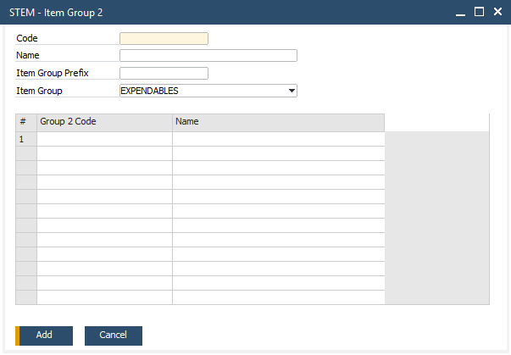
  - Group 3 disusun berdasarkan kombinasi Item Group + Group 2
Master data Group 3 dikaitkan dengan Item Group dan Group 2 tertentu. Setiap kombinasi Item Group dan Group 2 akan memiliki daftar Group 3 yang berbeda.
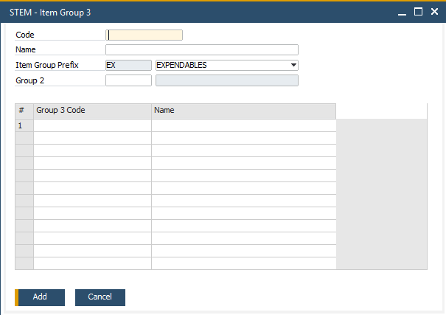
  - Group 4 disusun berdasarkan kombinasi Item Group + Group 2 + Group 3
Master data Group 4 dikaitkan dengan Item Group, Group 2, dan Group 3 tertentu. Setiap kombinasi tersebut akan memiliki daftar Group 4 masing-masing.
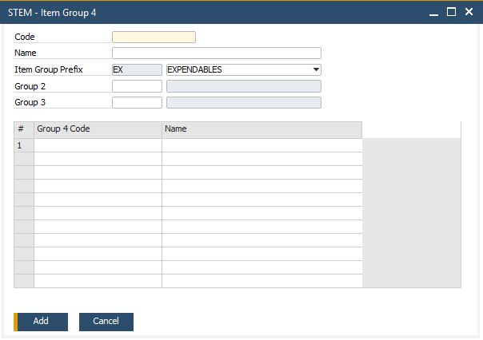
  - Group 5 disusun berdasarkan kombinasi Item Group + Group 2 + Group 3 + Group 4
Setiap kombinasi dari group sebelumnya memiliki daftar Group 5 tersendiri.
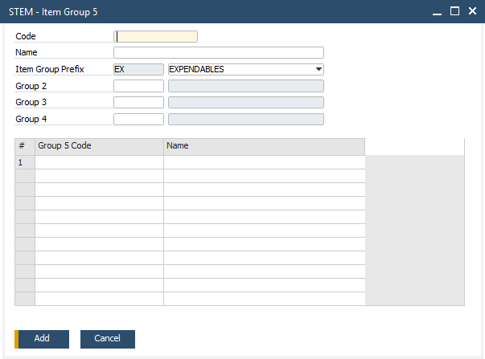
  - Group 6 disusun berdasarkan kombinasi Item Group + Group 2 + Group 3 + Group 4 + Group 5
Group 6 merupakan level paling detail dan sepenuhnya bergantung pada struktur group di atasnya.
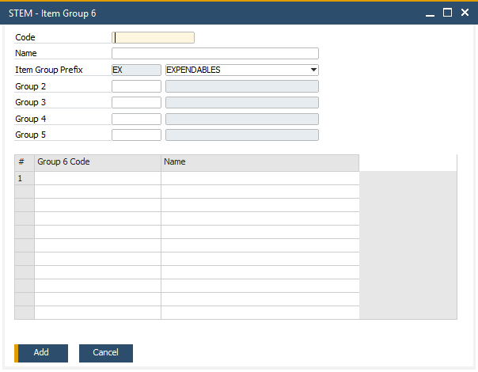
Dengan demikian, tidak ada Group tambahan yang berdiri sendiri tanpa keterkaitan dengan Item Group dan Group di atasnya.
- Menampilkan UDF Kode Barang/Jasa CoreTax pada screen Item Master Data, Tab General.
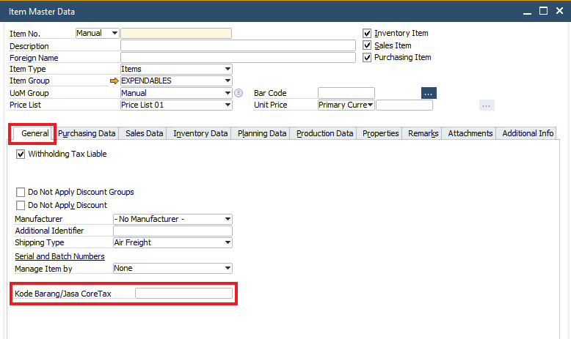
- Penambahan Tab Additional Info di Screen Item Master Data dan Tab tersebut berisi beberapa UDF tambahanyang terbagi dalam 2 subtab:
  - Subtab Item Data – berisi UDF yang berkaitan dengan Item Master.
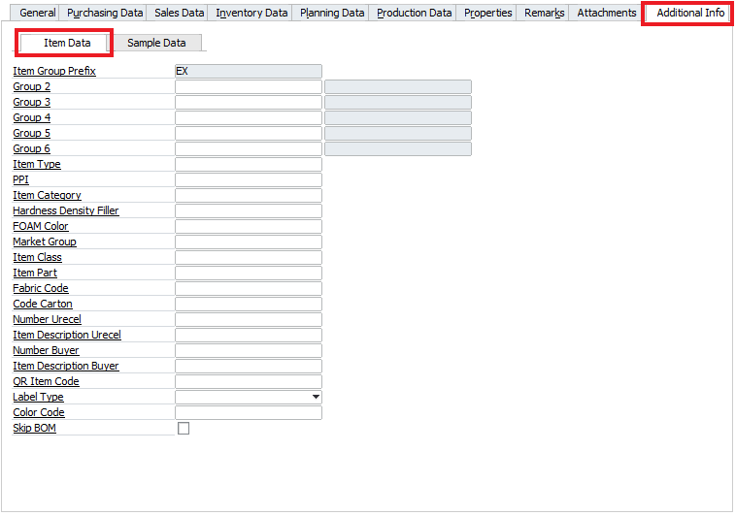

Beberapa UDF dengan kondisi khusus:
    - UDF Item Group Prefix otomatis terisi sesuai dengan Item Group yang dipilih.
    - Setelah mengisikan UDF Group 2 – Group 6, maka Item Code akan otomatis terisi. Item Code merupakan kombinasi isian pada Item Group Prefix, Group 2 – Group 6 dan running number.
    - UDF QR Item Code terisi otomatis dengan kondisi berikut:
      - Jika UDF Number Buyer terisi, maka UDF QR Item Code = UDF Number Buyer
      - Jika UDF Number Buyer dikosongkan, maka UDF QR Item Code = Item Code
    - UDF Skip BOM digunakan untuk menentukan apakah item akan dimunculkan pada tab BOM Structure saat melakukan Calculate BOM pada addon SQ Material Planner. Apabila dicentang, maka item tersebut tidak akan ikut diperhitungkan BOM-nya.

  - Subtab Sample Data – berisi UDF yang berkaitan dengan data item sampel.
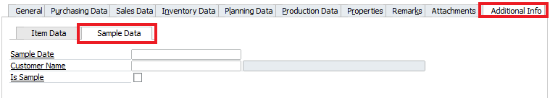

Apabila mengisikan seluruh data pada tab Additional Info, subtab Sample Data, maka field Create QR Code From pada tab Sales Data akan otomatis terisi link akses halaman iReapBiz untuk melihat informasi detail mengenai sampel.
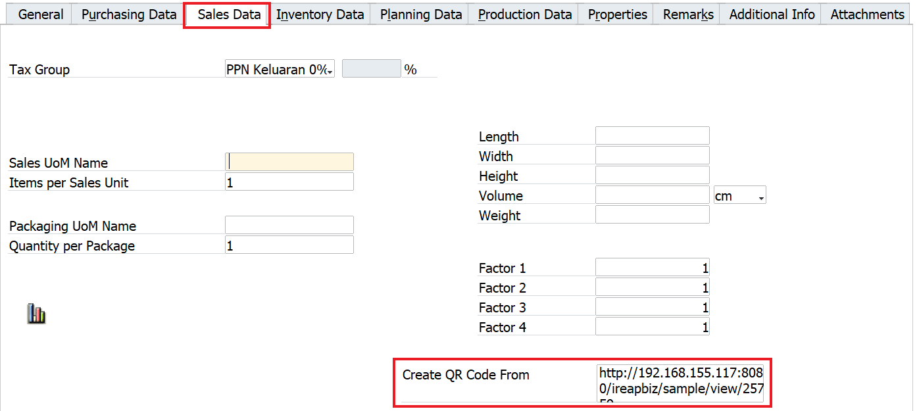

- Addon Excel Mapper untuk melakukan pemetaan (mapping) data dari format excel ke format yang sesuai dengan struktur data SAP Business One sebelum proses unggah dilakukan.
  - Menu: Upload Addon > Excel Mapper.
  - Tersedia 3 Excel Mapper yaitu Item Master (mapping untuk upload item master), Sales Quotation (mapping untuk upload SQ), dan BOM (mapping untuk upload BOM).
  - Default data yang dimunculkan pada tabel detail diatur melalui tabel @STEM_XLCOLLIST.
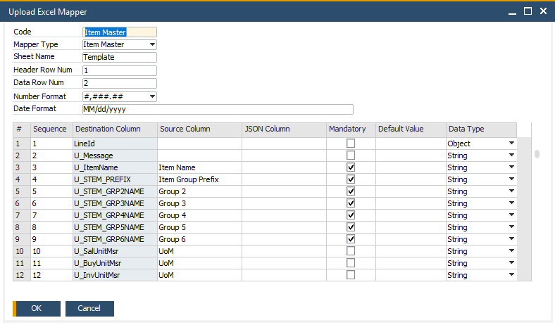

- Addon Upload Item Master untuk mengupload data Item Group dan Item Master dari format excel ke dalam sistem SAP Business One.
  - Menu: Upload Addon > Upload Item Master.
  - Template file Excel yang digunakan sebagai acuan pengisian data Item Group maupun Item Master sebelum proses upload dapat diperoleh melalui tombol Open Template di screen Upload Item Master.
  - Pada file Template Excel, tersedia 4 sheet:
    - Sheet Template merupakan tempat mengisi data item yang akan di-upload.
    - Sheet Group merupakan tempat mengisi data item group yang akan di-upload. Sheet Group sudah terisi data Item Group Prefix dan Group 2 sampai Group 6 yang terdaftar di SAP, per saat pengambilan data template tersebut
    - Sheet Contoh Data berisi sampel pengisian data item.
    - Sheet Keterangan berisi penjelasan tiap kolom pada sheet Template & Group dan keterangan apakah masing-masing kolom merupakan Mandatory atau memiliki setting Default Value.
  - Jika ingin mengupload data Item Group, maka pada Mode pilih Upload Group. Maka hanya tab Group yang akan diaktifkan.
  - Jika ingin mengupload data Item Master, maka pada Mode pilih Upload Item. Maka hanya tab Item yang akan diaktifkan.
  - Masukkan data dari Template Excel ke addon Upload Item Master melalui tombol di File To Import. Setelah memilih file Excel, sistem akan langsung melakukan proses import dan validasi data pada file Excel.
    - Data yang memenuhi kriteria akan ditampilkan pada Tab Available.
    - Data yang tidak memenuhi kriteria akan ditampilkan pada Tab Skipped.
  - Simpan data dari File Excel yang sudah divalidasi dengan klik Add.
  - Selanjutnya untuk mengupload data tersebut ke SAP, maka klik tombol:
    - Upload Group untuk mengupload data Item Group
    - Upload Item untuk mengupload data Item Master.
      - Apabila data item berhasil di-upload, maka pada Tab Posted, kolom Item Code akan terisi dengan kode item beserta dengan panah emas untuk membuka Item Master Data.
      - Kolom STEM Prefix dan Group 2 Name – Group 6 Name pada file Excel, sheet Template digunakan sebagai dasar pembuatan Item Code secara otomatis saat di-upload ke SAP.
      - Apabila gagal upload, maka akan ditampilkan pesan di Tab Posted, kolom Message.
  - Tampilan Upload Item Group:
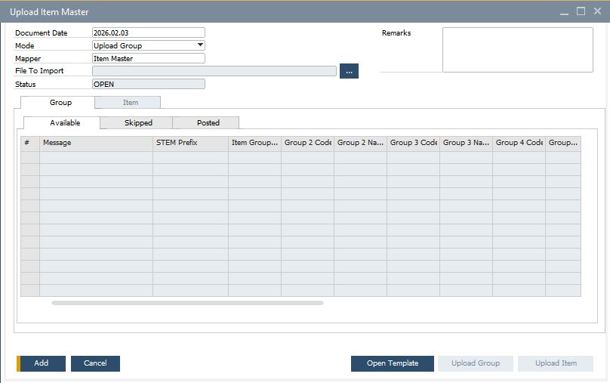
  - Tampilan Upload Item Master:
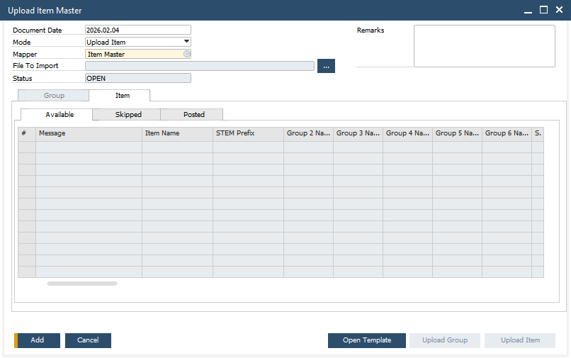

Formatted Search
No | Field | Setup | Auto Refresh
 | FMS untuk memilih Unit of Measure (UoM), dimana daftar satuan akan ditampilkan pada jendela STEM – FMS Unit of Measure.
 | BuyUnitMsr (Purchasing UoM Name)  PurPackMsr  (Packaging UoM Name)  SalUnitMsr (Sales UoM Name)  SalPackMsr  (Packaging UoM Name)  InvntryUom (UoM Name) | Without Search in User-Defined Values  Search in Existing User-Defined Values  Search in Existing User-Defined Valued according to Saved Query | Auto Refresh When Field Changes
  Saved Query
  STEM – FMS Unit of Measure

User-Defined Field (UDF)
- Penambahan UDF Kode Barang/Jasa CoreTax di tab General, digunakan pada addon CoreTax.
No | Title | Description | Type | Validation
 | STEM_CT_KODEBARANG | Kode Barang/Jasa CoreTax | Alphanumeric (30) | None

- Penambahan UDF GRPO Tolerance (%) di tab Purchasing Data, digunakan untuk menentukan batas penerimaan barang saat dilakukan Goods Receipt PO. Jika terisi dengan angka lebih besar dari 0, tandanya Qty GRPO boleh melebihi Qty PO, sampai batas persentase yang terisi di UDF tersebut.
No | Title | Description | Type | Validation
 | STEM_GRPOTOLERANCE | GRPO Tolerance (%) | Percents | None

- Penambahan UDF pada tab Additional Info, subtab Item Data
No | Title | Description | Type | Validation
 | STEM_PREFIX | Item Group Prefix | Alphanumeric (2) | None
 | STEM_GRP2CODE | Group 2 Code | Alphanumeric (2) | None
 | STEM_GRP2NAME | Group 2 Name | Alphanumeric (200) | None
 | STEM_GRP3CODE | Group 3 Code | Alphanumeric (2) | None
 | STEM_GRP3NAME | Group 3 Name | Alphanumeric (200) | None
 | STEM_GRP4CODE | Group 4 Code | Alphanumeric (2) | None
 | STEM_GRP4NAME | Group 4 Name | Alphanumeric (200) | None
 | STEM_GRP5CODE | Group 5 Code | Alphanumeric (4) | None
 | STEM_GRP5NAME | Group 5 Name | Alphanumeric (200) | None
 | STEM_GRP6CODE | Group 6 Code | Alphanumeric (3) | None
 | STEM_GRP6NAME | Group 6 Name | Alphanumeric (200) | None
 | STEM_ITEMTYPE | Item Type | Alphanumeric (100) | None
 | STEM_PPI | PPI | Alphanumeric (100) | None
 | STEM_ITEMCAT | Item Category | Alphanumeric (100) | None
 | STEM_HDF | Hardness Density Filler | Alphanumeric (100) | None
 | STEM_FOAM_COLOR | FOAM Color | Alphanumeric (100) | None
 | STEM_ITM_MKT | Market Group | Alphanumeric (100) | None
 | STEM_ITM_CLASS | Item Class | Alphanumeric (100) | None
 | STEM_ITM_PART | Item Part | Alphanumeric (100) | None
 | STEM_ITM_FBR | Fabric Code | Alphanumeric (100) | None
 | STEM_ITM_CC | Code Carton | Alphanumeric (100) | None
 | STEM_ITM_SKUU | Number Urecel | Alphanumeric (50) | None
 | STEM_ITM_DSCRIPTIONU | Item Description Urecel | Alphanumeric (200) | None
 | STEM_ITM_SKUB | Number Buyer | Alphanumeric (50) | None
 | STEM_ITM_DSCRIPTIONB | Item Description Buyer | Alphanumeric (200) | None
 | STEM_QRITEMCODE | QR ItemCode | Alphanumeric (50) | None
 | STEM_LBLTYP | Label Type | Alphanumeric (10) | Valid Values:  - Type A - Type A  - Type B - Type B  - Type C - Type C  - Type D - Type D  - Type E - Type E  - Type F - Type F  - Type G - Type G  - Type H - Type H  - Type I - Type I  - Type J - Type J
 | STEM_COLOR | Color Code | Alphanumeric (100) | None
 | STEM_SKIPBOM | Skip BOM | Checkbox | None  Default Value:  N – No

- Penambahan UDF pada tab Additional Info, subtab Sample Data
No | Title | Description | Type | Validation
 | STEM_SAMPLEDATE | Sample Date | Date | None
 | STEM_CUSTID | Customer ID | Alphanumeric (100) | None
 | STEM_CUSTNAME | Customer Name | Alphanumeric (200) | None
 | STEM_SAMPLE | Is Sample | Checkbox | None  Default Value:  N – No

User Defined Object (UDO)
- Penambahan 5 UDO untuk me-maintain Master Data dari masing-masing Group 2 sampai dengan Item Group 6.
No | # | Value
 | Unique ID | STEM_GROUP2
 | Name | Group2
 | Type | Master Data
 | Table Name | STEM_GROUP2, STEM_GROUP2D
 | Apply Authorization | N
 | UI | Using SAP Default Form (Matrix Style)  Menu: Inventory > STEM Item Group > Group 2  Tampilan:
2 | Unique ID | STEM_GROUP3
2 | Name | Group3
2 | Type | Master Data
2 | Table Name | STEM_GROUP3, STEM_GROUP3D
2 | Apply Authorization | N
2 | UI | Using SAP Default Form (Matrix Style)  Menu: Inventory > STEM Item Group > Group 3  Tampilan:
3 | Unique ID | STEM_GROUP4
3 | Name | Group4
3 | Type | Master Data
3 | Table Name | STEM_GROUP4, STEM_GROUP4D
3 | Apply Authorization | N
3 | UI | Using SAP Default Form (Matrix Style)  Menu: Inventory > STEM Item Group > Group 4  Tampilan:
4 | Unique ID | STEM_GROUP5
4 | Name | Group5
4 | Type | Master Data
4 | Table Name | STEM_GROUP5, STEM_GROUP5D
4 | Apply Authorization | N
4 | UI | Using SAP Default Form (Matrix Style)  Menu: Inventory > STEM Item Group > Group 5  Tampilan:
5 | Unique ID | STEM_GROUP6
5 | Name | Group6
5 | Type | Master Data
5 | Table Name | STEM_GROUP6, STEM_GROUP6D
5 | Apply Authorization | N
5 | UI | Using SAP Default Form (Matrix Style)  Menu: Inventory > STEM Item Group > Group 6  Tampilan:

- Penambahan 2 UDO untuk kebutuhan upload Item Master Data.
No | # | Value
1 | Unique ID | STEM_XLMAPPER
1 | Name | Excel_Mapper
1 | Type | Master Data
1 | Table Name | STEM_XLMAPPERH, STEM_XLMAPPERD
1 | Apply Authorization | N
1 | UI | Using SAP Default Form (Matrix Style)  Menu: Upload Addon > Excel Mapper  Tampilan:
2 | Unique ID | STEM_UPLOADITM
2 | Name | STEM_UploadItem
2 | Type | Master Data
2 | Table Name | STEM_UPLOADITMH, STEM_UPLOADITMD, STEM_UPLOADITMD1, STEM_UPLOADITMD2, STEM_UPLOADGRPD, STEM_UPLOADGRPD1, STEM_UPLOADGRPD2
2 | Apply Authorization | N
2 | UI | Using SAP Default Form (Matrix Style)  Menu: Upload Addon > Upload Item Master  Tampilan:  Untuk upload Item Group & Item Master dibedakan dari Mode.

- Penambahan UDO untuk kebutuhan mengatur extension yang diperbolehkan pada Sample Attachment.
No | # | Value
1 | Unique ID | STEM_SAMPLE_ATT
1 | Name | STEM_SAMPLE_ATTACHMENT
1 | Type | Master Data
1 | Table Name | STEM_SAMPLE_ATT
1 | Apply Authorization | N
1 | UI | Using SAP Default Form (Matrix Style)  Menu: Administration > STEM Web Sample Attachment  Tampilan:  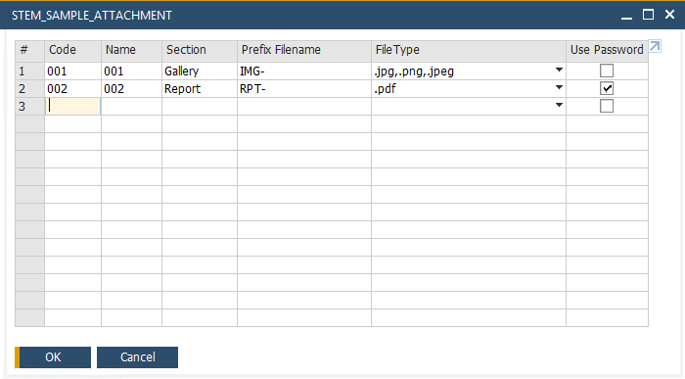

User Defined Table (UDT)
- STEM XLCOLLIST
  - UDT ini untuk mengatur default data yang dimunculkan pada tabel detail dari menu Excel Mapper.
  - Field pada UDT ini
Field | Penjelasan
Code | Diisi dengan
Name | Dapat disamakan dengan isian pada field Code
Mapper Type | Tersedia pilihan Item Master, Sales Quotation, dan BOM
Sequence | Diisi dengan nomor urut agar kolom yang ditampilkan di menu Excel Mapper dapat berurutan. Urutan ini dibuat per Mapper Type
Source Column | Diisi dengan nama kolom yang akan dimunculkan di Excel Mapper
Destination Column | Diisi dengan nama kolom tujuan ketika dilakukan upload data
JSON Column | Diisi dengan nama kolom untuk JSON
Mandatory | Dicentang apabila kolom terkait wajib diisi
Data Type | Diisi dengan tipe data (object, string, date, number, integer, double)
Default Value | Diisi dengan nilai default untuk kolom terkait

  - UDT ini tidak ditampilkan
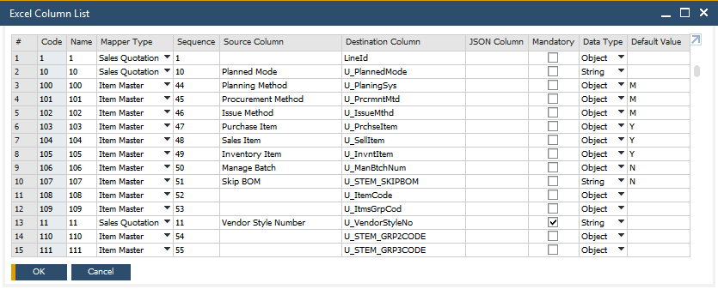

- ST_PARAM – STEM Addon Parameter
  - UDT ini untuk menyimpan parameter untuk mengatur default value pada berbagai transaksi maupun tampilan di dalam SAP Business One dan aplikasi lain yang terintegrasi dengan SAP Business One.
  - Field pada UDT ini
Field | Penjelasan
Code | Diisi dengan nomor urut.
Name | Dapat disamakan dengan isian pada field Code.
Description | Diisi dengan penjelasan parameter akan digunakan dimana.
Parameter Value | Diisi dengan nilai default dari parameter
Parameter Key | Diisi dengan kode/nama/key parameter

  - Addon Parameter yang ditambahkan, yaitu:
No | Description | Parameter Value | Parameter Key
 | URL Untuk sample ireap biz – Sample in iReapBiz | http://192.168.155.117:8080/ ireapbiz/sample/view/  Note:  Sampai saat ini masih menggunakan IP Local dan belum di-publish ke Pelanggan. | URLIREAPBIZ
 | DB Direct User for Query Upload - Upload Addon | STEMUPLOAD | STEMUPLOAD_DBUSER
 | DB Encrypted Password for Query Upload - Upload Addon | HEJ34jTdjbIqBEd7+zv1ew== | STEMUPLOAD_DBPASS

  - Dapat diakses dari menu Tools > User-Defined Windows > ST_PARAM – STEM Addon Parameter.
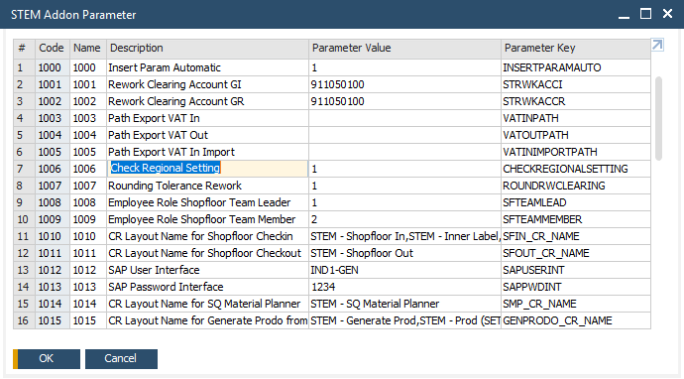

Other
- Saved Query
No | Query Category | Query Name | Query
 | FMS | STEM – FMS Unit of Measure | SELECT T0."UomCode", T0."UomName"  FROM OUOM T0  ORDER BY T0."UomCode"

- Sample in iReapBiz
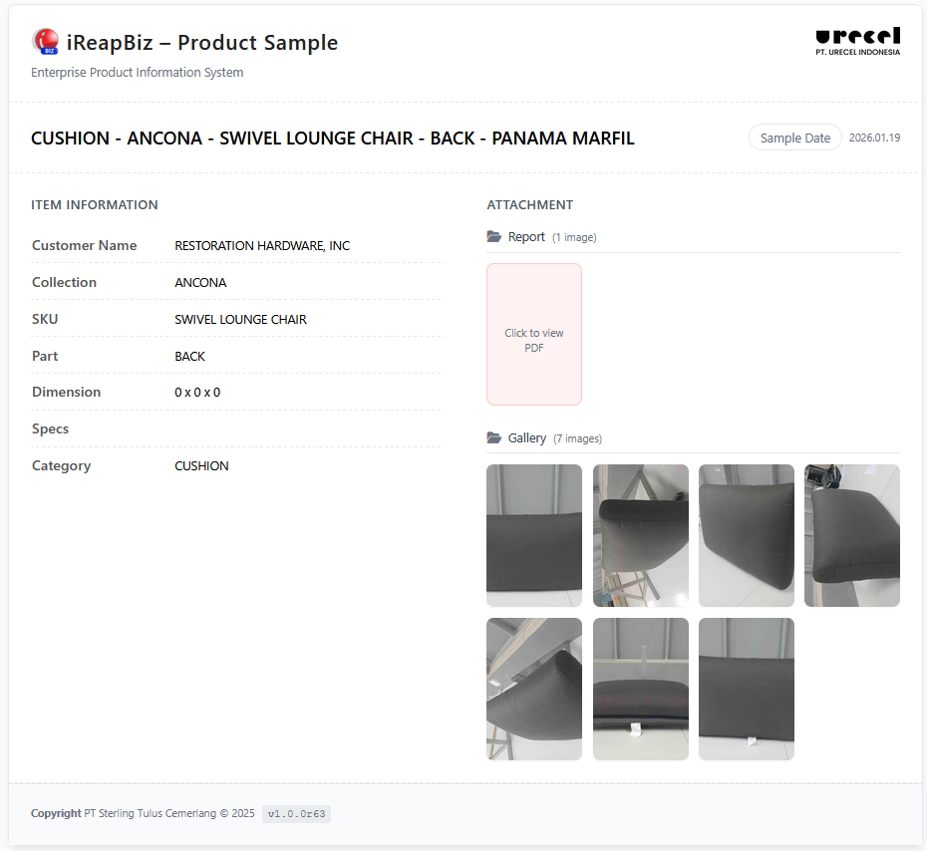
  - Agar pelanggan Urecel dapat melihat informasi, foto, dan dokumen terkait sampel, maka disediakan halaman khusus di iReapBiz untuk menampilkan informasi tersebut.
  - Hal dibawah ini wajib dilengkapi pada Item Master Data agar dapat melihat data sampel pada iReapBiz:
    - Informasi seperti nama item dan data di tab Additional Info, Subtab Item Data.
    - Informasi terkait sampel pada tab Additional Info, Subtab Sample Data. Dengan mengisikan seluruh data pada Subtab Sample Data, saat klik Add (jika membuat item master data baru) atau Update (jika mengubah dari item master yang sudah ada), maka link untuk mengakses data sampel di iReapBiz akan otomatis muncul pada Tab Sales Data, field Create QR Code From.
    - Foto dan dokumen pendukung sampel dapat dimasukkan pada Tab Attachment. Saat ini Extension untuk foto yang dapat dimunculkan pada iReapBiz, yaitu .jpg, .png, .jpeg. Sementara Extension untuk dokumen yaitu .pdf. Khusus untuk dokumen, diatur agar untuk membuka dokumen dibutuhkan password. Pengaturan ini dapat dilakukan melalui menu STEM – Web Sample Attachment.

Report
- STEM - QR Item Sample
  - Untuk mencetak QR dari item sampel.
  - Menu : Inventory > Inventory Reports > STEM - QR Item Sample
  - SP : STEM_PRINTQR_ITEMSAMPLE
  - Size : 8 x 3 cm
  - Tampilan:
    - Selection Criteria
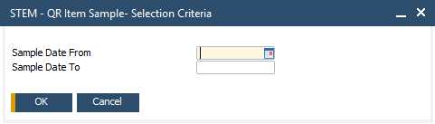
    - Layout
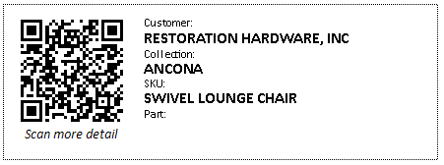

Integration
-

Comments
- Konversi item Legacy ke SAP B1 Item
- Team klien mengisikan template Item Master Data di Excel
- File Excel akan diperiksa dan diupload ke SAP oleh team STEM
- Update Standard Operational Procedure to be in line with SAP B1

Version Control
Date | Author | Version | Change Reference
05-Aug-2025 | Jennie Lou | 1.00 | First Draft
17-Sep-2025 | Happy Niti Noor Muchsin | 1.01 | Update Business Owner
26-Sep-2025 | Happy Niti Noor Muchsin | 1.02 | Review Blueprint
01-Oct-2025 | Jennie Lou | 1.03 | Update Penomoran Item
21-Jan-2026 | Chatrine Sylvia | 1.04 | Update Item Process Flow and Functional Gap

